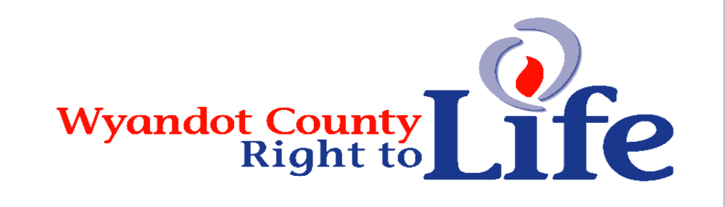

Wheat & Chaff Newsletter – Summer 2017

“You knit me in my mother’s womb . . . nor was my frame unknown to you when I was made in secret” (Psalm 139:13-15)
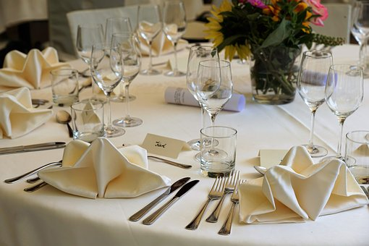
Bethel Ministries/Voice of Hope Annual Fall Banquet will be Sept 21st from 7-9 pm. This year the event will be hosted at All Occasions Catering at 6989 Waldo-Delaware Rd. The keynote speaker is Amy Ford, founder of Embrace Grace, Inc. Please check out her website http://embracegrace.com/. There will be an opportunity to give at the conclusion of the eventing. There will also be silent auction items to bid on, so please come early. Doors open at 6:30 and event begins promptly at 7:00 pm. Wyandot Co RTL members please call Carolyn Jolliff at 419-581-8504 by August 31st to reserve a spot at “our” table.

“You have been my guide since I was first formed . . . from my mother’s womb you are my God” (Psalm 22:10-11).


Thanks to everyone who has & who will support LIFE by becoming a 2017 member of Wyandot Co Right to Life! Please take the time to show your support for the dignity of all human life from conception til natural death by sending in your $6 (more greatly appreciated and will be used to promote LIFE) donation to: Wyandot County Right to Life, P.O. Box 381 Upper Sandusky, OH 43351-0381. Thanks and God bless each of you who have already sent in your membership donation and each of you who still will!
“God… from my mother’s womb had set me apart and called me through his grace” (St. Paul to the Galatians 1:15)

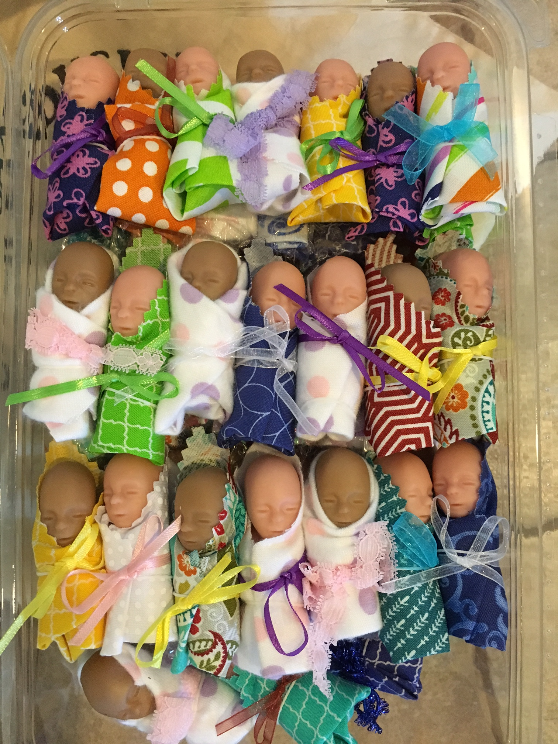
Fetal Babies – This year the true to life size & feel 12 week fetal babies at the LIFE Fairbooth will be clothed in a blanket & a ribbon. Please explain to your children (young & older) that these babies need treated with respect. Thanks for helping us make these Precious Ones a great learning tool for the Pro-Life cause!!! Life is God-given!!

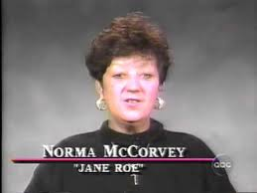
Norma McCorvey (“Jane Roe” of Roe v Wade) died at age 69. The plaintiff known as “Jane Roe” in the landmark U.S. Supreme Court Roe v. Wade case that legalized abortion in the United States, died on Feb 18, 2017 from heart failure. After years of advocating for legalized abortion, McCorvey later became pro-life. She came into the spotlight at age 22 when she became “Jane Roe” after she met two lawyers who she says exploited her situation to gain a victory for the abortion rights movement. She was pregnant, unmarried, dealing with addiction and poverty, and was looking for a way out of an unwanted pregnancy. Her case was based on the lie that she was raped. However, the case took so long that McCorvey ended up having her baby and placing the baby for adoption. Years later McCorvey joined the pro-life movement after pro-lifers befriended her outside the abortion clinic where she worked. A few years later, McCorvey joined the Catholic Church. (Source: Prolife Across America “The Billboard People” Mary Ann’s VIP News Summer 2017)

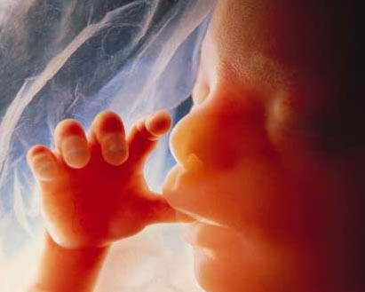
Learn More About Wyandot County Right To Life:
Our website: http://wyandotcountyrightolife.org/
(Note: right and to share a “t”) We have had 21, 574 views of our website as of 23 Aug 2017. Check us out!


**We regret that the federal government does not allow contributions to Wyandot County Right to Life to be tax deductible. If & only IF you would like your gift to be tax deductible, please make your check out to: Ohio Right to Life Educational Fund and in the MEMO box mark for the use of: Wyandot Co Right to Life!!!! We will be able to use these funds for educational activities and you will have a tax deduction! Please make all other donations payable to: Wyandot Co Right to Life. Your gift is important to us. We are all volunteers, so every penny goes toward our mission of respecting and protecting human life from conception til natural death. Please mail to: Wyandot Co Right to Life P O Box 381 Upper Sandusky, OH 43351-0381. Thanks & God Bless You!!!
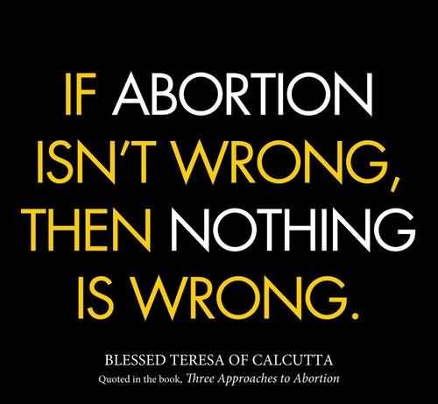
What Can I Do? 
- Pray for Respect for Human Life in our country and in the world. VOTE Pro-Life!
- Become a member of Wyandot County Right to Life ($6 dues donation & any additional donations will be used for the LIFE cause!
Work for Life – May we call you with volunteer opportunities? Yes PH_____________
- Support Wyandot County Right to Life with your gift of $________________________
If you choose your gift may be made:
In Memory of (name) __________________________________________
Mailing Address____________________________________________________________
Or for a birthday, anniversary or special event
In Honor of (name) _________________________________________________________
Mailing Address____________________________________________________________
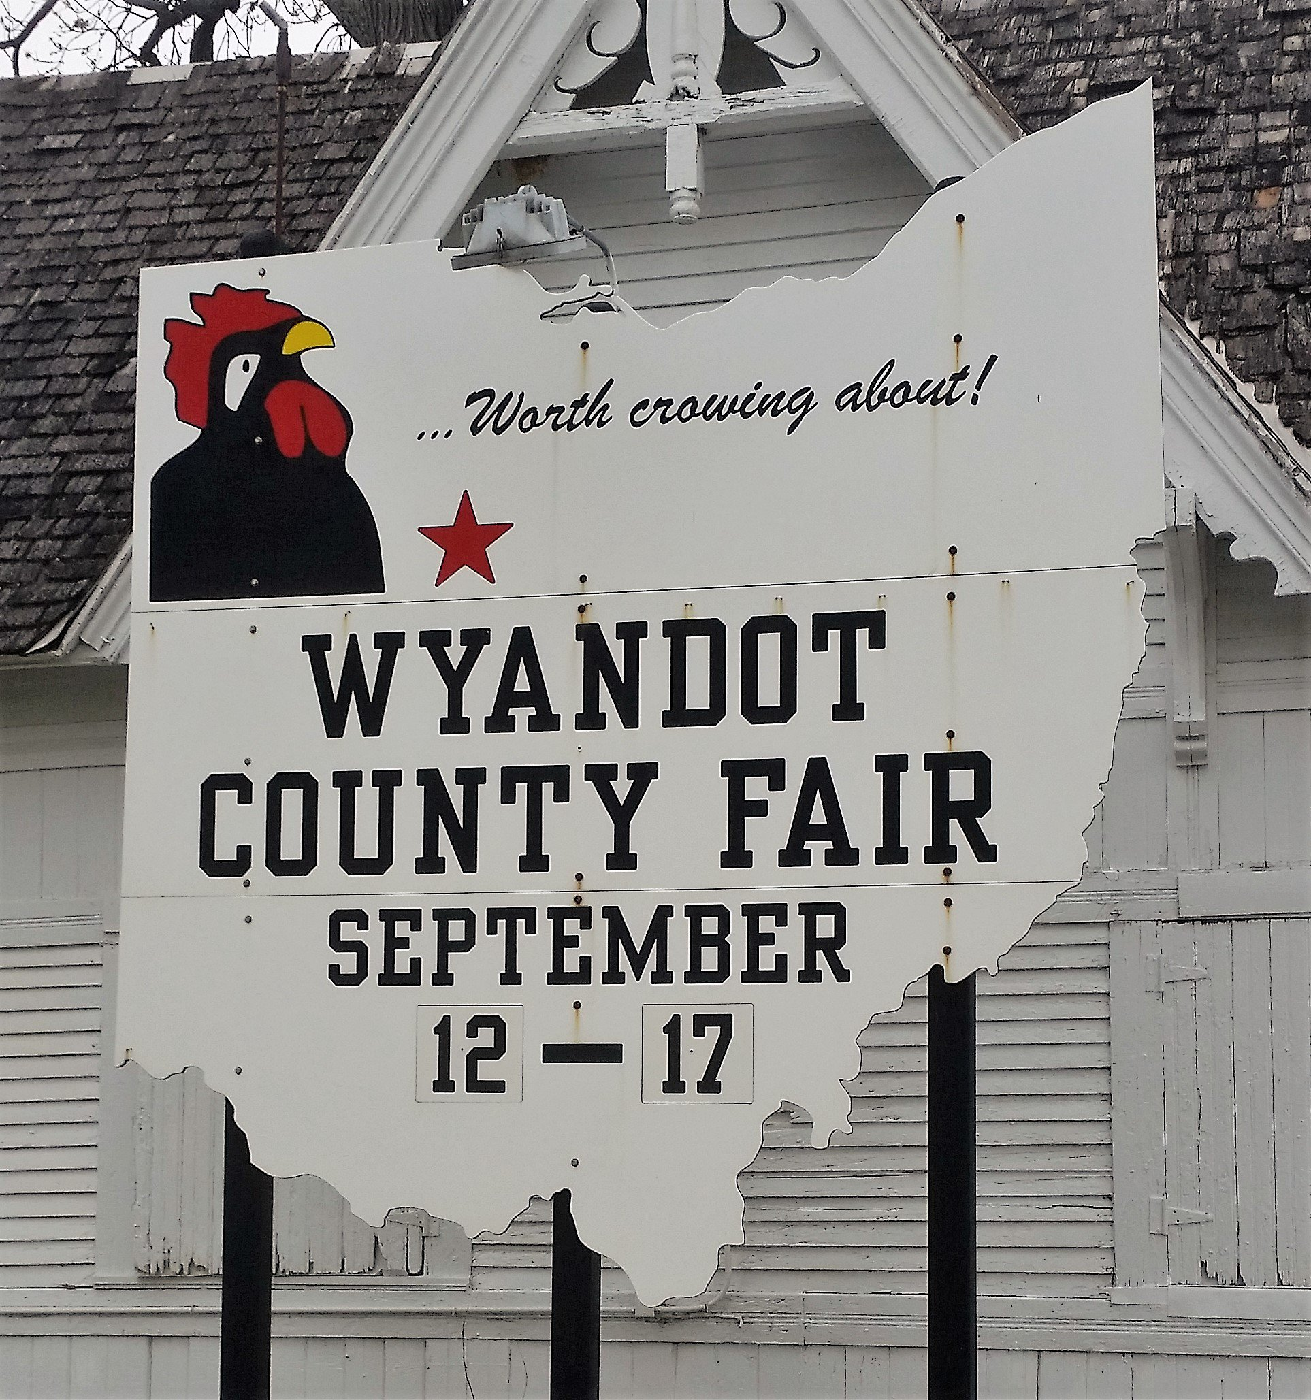
This year’s Wyandot County Fair theme is: Be Part of the Team in 17” We are adding the word “LIFE” to the fair theme of course!! Special thanks to the Upper & Carey K of C groups for their faithful support of the LIFE fair booth since our first booth!! Special thanks to our wonderful faithful day leaders: Tuesday: Andrea Gadomski Riker; Wednesday: Doris Daniel; Thursday:
Jean Ann Hoepf, Friday: Marie Frey, Saturday: Carolyn Jolliff, Sunday: Bethel Ministries. Thanks to everyone who staffs the booth!! God bless you all!!!


5th Annual National Day of Remembrance for Aborted Children, is calling on pro-life Americans to honor the grave sites and memorials of our aborted brothers and sisters. When: Saturday, September 9, 2017 at 1:00 PM. Where: Holy Cross Cemetery 100 E. Waterloo Rd. Akron, OH 44319. With the accompaniment of the Knights of Columbus Color Guard, memorial service participants to date include Pastor Al Davis (Bible Baptist Church, Richfield), Chris Long (President, Ohio Christian Alliance), Senator Frank Larose (Ohio Senate District 27), Ohio Lieutenant Governor Mary Taylor, Helena Carlson (President, University of Akron Students for Life) and keynote speaker Robin Swoboda. Music performed by Kira Leyden & Jeff Andrea.

Abortion in sign language: If you go to Hand Speak you will see an illustration of how you sign “abortion” in American Sign Language. If you look up ASL, it’s defined as “the primary language of many North Americans who are deaf and is one of several communication options used by people who are deaf or hard-of-hearing.” So it’s a big deal. In just two seconds the signer goes from a rocking motion, like a lullaby, to using her right hand to take out what would be the baby, and discard him/her in one quick motion by opening her fist. If you look at other options–at signingsavvy.com, for example—you see much the same sign. In the latter case the rocking gesture is lengthier and taking out what would be the baby is more obvious. You can go in a lot of different directions with this. But what struck me was if you look to the left, literally the first word on the ASL dictionary is “abandon.” The signs for abandon and abortion are different, of course, but the message of the two gestures is very similar: get out of here. (Source: http://www.nationalrighttolifenews.org/news/2017/08/a-two-second-video-can-be-worth-thousands-of-hits-and-retweets/#.WZ7v3jios74)


Governor John Kasich approved $1 million for Ohio Right to Life's Parenting and Pregnancy Support Program, an initiative we formed in 2013 to provide state funds to life-affirming pregnancy centers. Ohio pregnancy centers now have the opportunity to apply for this funding - the only question is, "How?" In collaboration with our friends at Heartbeat International, Ohio Right to Life will answer that question on Friday, September 8 at our Funds for Life Training Session, a training dedicated to explaining how to apply for funding through the Ohio Parenting and Pregnancy Support Program. In years past, there has been a lot of confusion about the application process. The truth is, the application process is rather rigorous and requires careful planning and writing to guarantee consideration. But as intimidating as that may sound, there are plenty of fantastic resources right here in Ohio that can help you as you set out to apply for these funds. When: Friday, September 8 from 10 am - 2 pm. Where: Keybank Bldg. 88 Broad St Columbus, OH 43215. The goal of our training is to connect you to these resources, answer your questions, and set you up for success in your efforts to secure funding for your life-saving efforts! If you are interested in attending this event, kindly RSVP to me, Jessica Koehler, at 614.547.0099 ext. 303 by Wednesday, September 6.

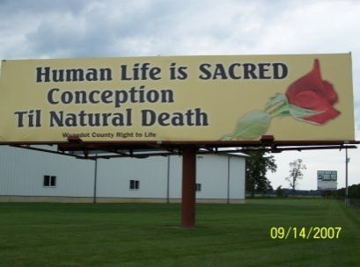
Wyandot County Right to Life
Non Profit
U.S. Postage
Paid
Marion, OH
Permit # 23
P.O. Box 381
Upper Sandusky, OH 43351-0381
RETURN SERVICE REQUESTED


Take heed that ye despise not one of these little ones; for I say unto you, That in heaven their angels do always behold the face of my Father which is in heaven. Matthew 18:10 (KJV)

“All life has inestimable value. Even the weakest and most vulnerable, the sick, the old, the unborn, and the poor, are masterpieces of God’s creation, made in His own image, destined to live forever, and deserving of the utmost reverence and respect.” – Pope Francis

Billionaire Musk’s surprising tweet: World headed toward collapse without more children. Some of the world’s countries are not replacing themselves in population and they are in danger of demographic collapse. Musk’s analysis focused on the productivity of people in their respective demographics — not a measure of the value of life — but it does factor concretely into civic planning. Societies need future generations to logistically sustain themselves. Musk mentioned as well how immigration is not a feasible method of population replacement. Musk may be an unlikely dispatcher of a pro-life message. (Source: https://www.lifesitenews.com/news/billionaires-surprising-tweet-world-headed-toward-collapse-without-more-chi?utm_source=LifeSiteNews.com&utm_campaign=6981ac80fb-Daily%2520Headlines%2520-%2520U.S.&utm_medium=email&utm_term=0_12387f0e3e-6981ac80fb-401399961)

