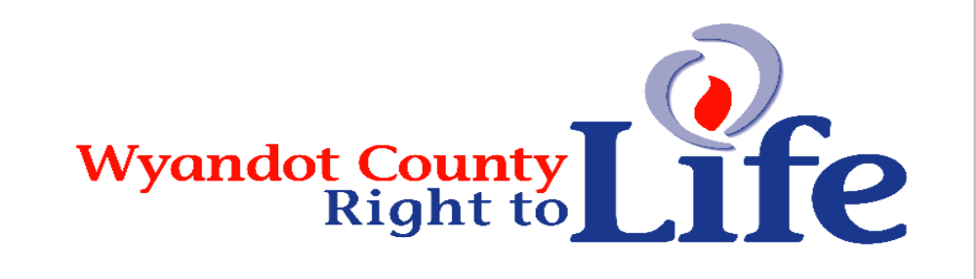

Wheat & Chaff Newsletter – Fall 2016

“You have been my guide since I was first formed . . . from my mother’s womb you are my God” (Psalm 22:10-11).
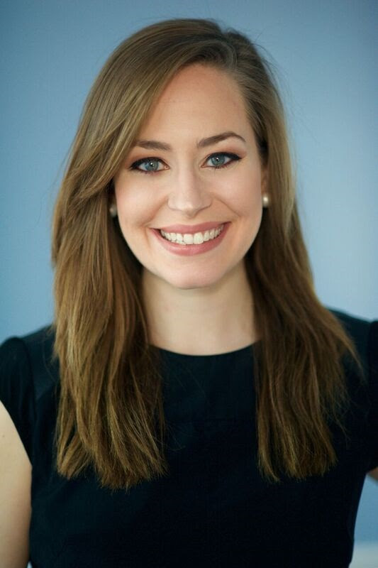
When we reveal the numbers showing Planned Parenthood is focused on abortion and not women's health care, people's minds change. Planned Parenthood's repeated lie that abortion is "only three percent" of what they do. Planned Parenthood is spending an unprecedented $30 million to influence the election this fall and spread lies like this to ensure their half billion dollars a year in taxpayer subsidies keep flowing. Planned Parenthood will make sure 887 babies are killed today alone through abortion - that's one precious child EVERY 97 seconds of EVERY day. This is America's largest abortion corporation - and they are determined to stay in business at the taxpayers' expense. (Source: Lauren Merz Director of Strategic Partnerships Live Action 2200 Wilson Blvd, Suite 102 #111
Arlington, VA 22201)
We announced an event coming up on October 20 which will feature Dinesh D’Souza, creator of the film Hillary’s America. It will take place in Grove City (western suburb of Columbus) at Grove City Church of the Nazarene. We are quite excited to have Mr. D’Souza speak and would like to take a moment to invite you to attend. We invite you to promote the event to your members, friends, neighbors, churches, etc... Please feel free to direct people to this link for more information and to purchase tickets: www.ohiolife.org/dinesh. (Source: Devin Scribner Executive Director Ohio Right to Life 88 East Broad Street, Suite 620 Columbus, Ohio 43215 614/547-0099 www.ohiolife.org)

There are a number of ways we can actually defeat a pro-life candidate. For the sake of the babies, we cannot afford to make these mistakes in 2016. Here’s what NOT to do: Fall in love with your candidate. Support a really nice candidate who is pro-life but has no chance of winning. Expect the candidate to sound like a Right to Life chapter chairman. Expect the candidate to
always make abortion the major issue in the campaign. Vote for a third-party or independent candidate who has no chance of winning. Again, on November 8, either Hillary Clinton or Donald Trump will be elected President. Hillary Clinton voted in favor of partial-birth abortion, supports dismemberment abortions, and has pledged to only appoint pro-abortion justices to the U.S. Supreme Court. (Source: National Right to Life News www.NRLC.org)

“You knit me in my mother’s womb . . . nor was my frame unknown to you when I was made in secret” (Psalm 139:13-15)

Thanks to everyone who supported LIFE by becoming a 2016 member of Wyandot Co Right to Life! If you haven’t taken the time to show your support for the dignity of all human life from conception til natural death you can still send in your $6 (more greatly appreciated and will be used to promote LIFE) donation to Wyandot County Right to Life, P.O. Box 381 Upper Sandusky, OH 43351-0381. Thanks and God bless each of you who have already sent in your membership donation and each of you who still will!
“God… from my mother’s womb had set me apart and called me through his grace” (St. Paul to the Galatians 1:15)

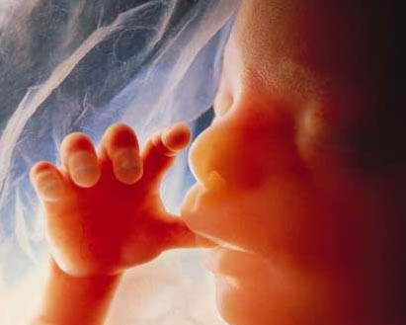
Learn More About Wyandot County Right To Life:
Our website: http://wyandotcountyrightolife.org/
(Note: right and to share a “t”) We have had 19,690 views of our website as of 22 Sep 2016. Check us out!

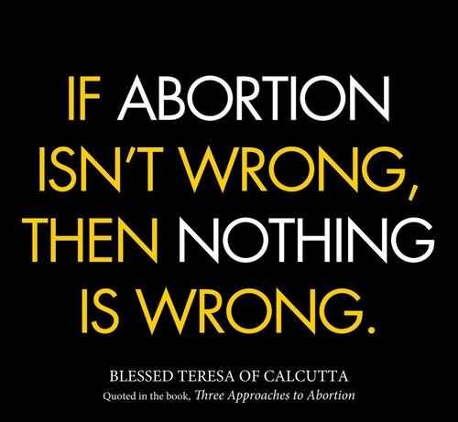

What Can I Do? 

- Pray for Respect for Human Life in our country and in the world. VOTE Pro-Life!
- Become a member of Wyandot County Right to Life ($6 dues donation)
- Work for Life – May we call you with volunteer opportunities? Yes PH_____________
- Support Wyandot County Right to Life with your gift of $________________________
If you choose your gift may be made
In Memory of (name) __________________________________________
Mailing Address____________________________________________________________
Or for a birthday, anniversary or special event
In Honor of (name) _________________________________________________________
Mailing Address____________________________________________________________
~~~~~~~~~~~~~~~~~~~~~~~~~~~~~~~~~~~~~~~~~~~~~~~~~~~~~~~~~~~~~~~~~~~~
**We regret that the federal government does not allow contributions to Wyandot County Right to Life to be tax deductible. If you would like your gift to be tax deductible, please make your check out to: Ohio Right to Life Educational Fund and in the
MEMO box mark for the use of: Wyandot Co Right to Life!!!! We will be able to use these funds for educational activities and you will have a tax deduction! Your gift is important to us. We are all volunteers, so every penny goes toward our mission of respecting and protecting human life from conception til natural death. Please mail to: Wyandot Co Right to Life P O Box 381 Upper Sandusky, OH 43351-0381. Thanks & God Bless You!!!

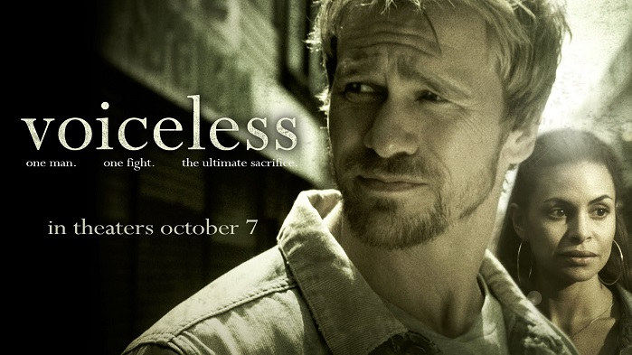
A new Christian pro-life movie won several awards recently ahead of its official release in October. “Voiceless” is a new film drama that follows Jesse Dean (played by Rusty Joiner), a discharged soldier who discovers an abortion clinic operating right across the street from his Philadelphia church. Jesse struggles to motivate his church to get involved in protecting unborn babies, and eventually must decide whether to risk it all to fight for what is right. One of the filmmakers’ key hopes for “Voiceless” is that it will engage and motivate more church-goers to become actively involved in reaching out to help pregnant moms and their unborn babies. “Voiceless is the first pro-life film that powerfully addresses the reasons why most people don’t engage the injustice of abortion. This film is brilliantly designed to inspire the church to action,” Joe Baker, CEO Save The Storks, said. Jason Jones, an executive producer of the film, described the new movie as “thoughtful, sympathetic and non-judgmental.” A strong pro-life advocate, Jones is well known for his work on the pro-life films “Crescendo” and “Bella.” “It’s real but it’s attractive,” Jones said of the new film, “and is the 1-2 knockout punch to Planned Parenthood.” “Voiceless” will be shown in theaters beginning Oct. 7. The film is rated PG-13 for some violence and thematic elements. (Source: http://www.lifenews.com/2016/09/20/pro-life-movie-voiceless-wins-best-feature-film-awards-at-multiple-film-festivals/)


Wyandot Co Right to Life wishes to Thank You for purchasing the RTL Geraniums in May and hope they did well for you this summer. People have told us that theirs did! Thanks to all who purchased the LIFE red carnations! Thanks to the local Church Day Leaders and staffers of the LIFE Booth at the Wyandot County Fair! Thanks to the Carey & the Upper K of C groups for sponsoring the LIFE Fair Booth! Your President wishes to Thank everyone for their kindness and understanding during her Mom’s illness and death! God bless each of you!

I’m CHRISTIAN and I VOTE - We know that if just 75% of conservative Christians vote in every election (instead of the typical 60-65%), the liberal-Left will never win another national election in our lifetime. If we can get 12,000,000 of the eligible 17,000,000 conservative Christian voters to the polls in 2016 who failed to vote in 2012, we will see sweeping conservative victories in 2016. In a few short weeks, we will know if the America you love can be saved, or is lost forever. (Source: Faith & Freedom Coalition P.O. Box 957736 Duluth,GA 30095-9529 www.ffcoalition.com 770-622-1501)

It is our duty as Christians and as citizens to participate in prayer for the elections and those who seek to gain power to lead. But are we to pray only and not vote? "So you see, faith by itself isn't enough. Unless it produces good deeds, it is dead and useless. Now someone may argue, "Some people have faith; others have good deeds." But I say, "How can you show me your faith if you don't have good deeds? I will show you my faith by my good deeds." You say you have faith, for you believe that there is one God. Good for you! Even the demons believe this, and they tremble in terror. How foolish! Can't you see that faith without good deeds is useless?" (James 2:17-20, NLT) Some may say that the Bible doesn't say vote so I'm not doing it. Well, I haven't read in the Bible that we are to flush the commode after we use it, but I still do it. Seriously. Is anyone getting this? So we pray in faith and then go to work—in this instance, vote. With our votes we can elect godly men and women who will make laws that conform to biblical values. (Source: Alveda King http://www.charismanews.com/opinion/45753-what-the-bible-says-about-christian-voting-at-elections)
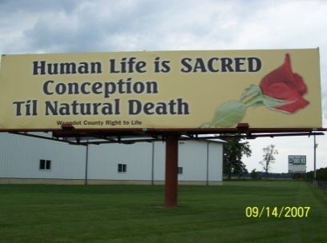
Wyandot County Right to Life
Non Profit
U.S. Postage
Paid
Marion, OH
Permit # 23
P.O. Box 381
Upper Sandusky, OH 43351-0381
RETURN SERVICE REQUESTED

A new documentary exposes prevalent deceptions about euthanasia by telling the stories of people who have firsthand experience with it: nurses, family members of the euthanized, bioethicists, and the disabled and their families. Euthanasia Deception, produced by Euthanasia Prevention Coalition executive director Alex Schadenberg and Kevin Dunn, dismantles three lies that the euthanasia movement promotes: assisted death is compassionate, euthanasia is all about individual autonomy, and legal safeguards will protect the vulnerable. Euthanasia and assisted suicide are “falsely promoted as compassion and mercy,” when really “it’s about ending the life of someone who’s going through a very vulnerable time,” he said. The doctor who causes a patient’s death is the one who must send in the report, making it extremely unlikely that a doctor would report himself for abusing the law. Another disturbing aspect of euthanasia in Belgium is that doctors list the causes of death of those they kill as whatever health problem the patient was experiencing — not lethal injection even though the injection is what kills the patient, Schadenberg said. Everyone should watch Euthanasia Deception to learn about increasing and deadly threats to the vulnerable — and then join the movement to stop the barbarism that is doctors killing their patients. (Source: Claire Chretien https://www.lifesitenews.com/news/new-documentary-pulls-back-curtain-on-euthanasias-most-powerful-deceptions)

Cradle My Heart Pro-Life Radio Program on WXML 90.1 at 9 pm each Sunday. Kim Ketola, host, experienced abortion as a young woman and understands what other women are going through. Wyandot Co Right to Life is a Day Sponsor on Oct 7th and also on Jan 22nd.

