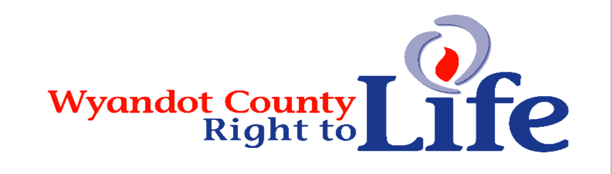

Wheat & Chaff Newsletter – Winter 2015

Silent Night Holy Night
Wishing You the Joy of Family, the Happiness of Friends
And the Wonder of the Holy Christmas Season

“You knit me in my mother’s womb . . . nor was my frame unknown to you when I was made in secret” (Psalm 139:13-15)

Thanks to everyone who supports LIFE! Become a 2016 member of Wyandot Co Right to Life! It’s time show your support for the dignity of all human life from conception til natural death. Send your $6 (more greatly appreciated and will be used to promote LIFE) donation to Wyandot County Right to Life, P.O. Box 381 Upper Sandusky, OH 43351-0381. Thanks and God bless!
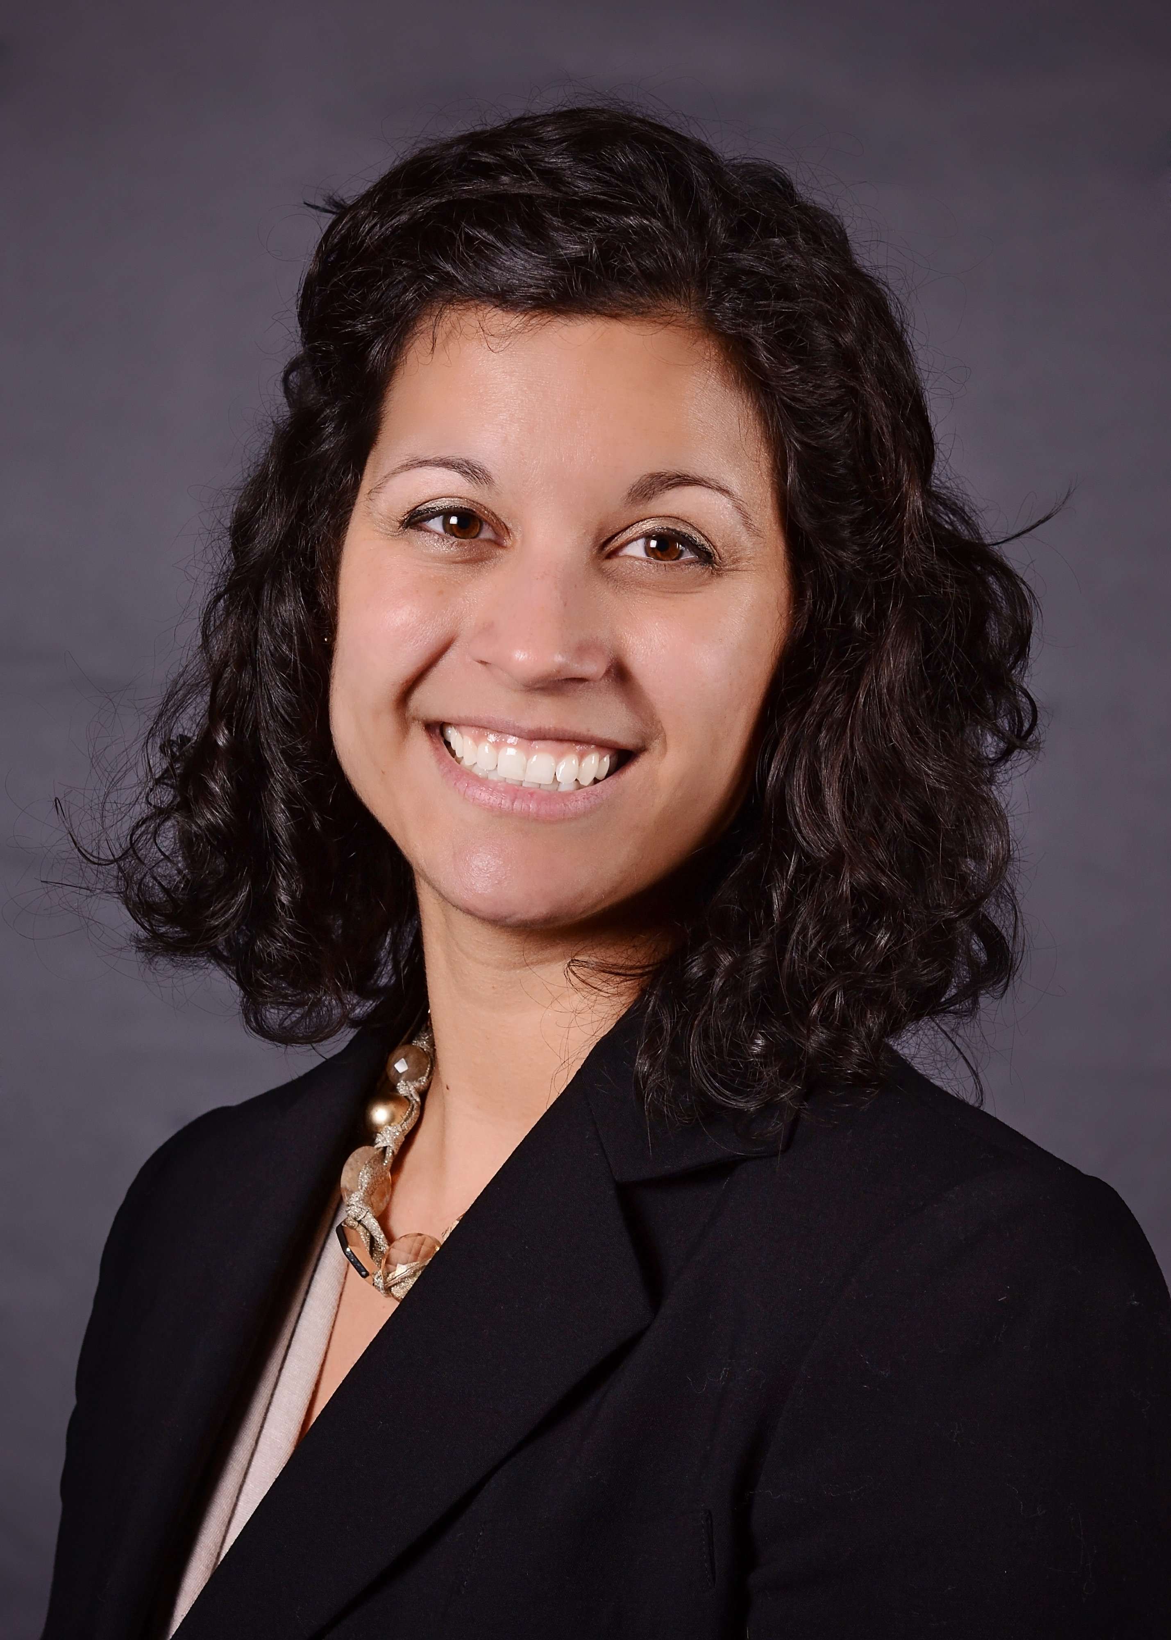
Ohio's pro-life model is working. Our state is flooded with choices: From 180 pregnancy center alternatives to Planned Parenthood, to real choice for how pro-life taxpayer dollars are spent. Ohio voters spoke loud and clear when we re-elected pro-life majorities to the Ohio General Assembly and pro-life Governor John Kasich in a landslide in 2014--despite the fact that they began de-funding Planned Parenthood and funding pregnancy centers in 2013! Now, all abortion advocates have left to attack are charitable organizations who provide parenting classes, cribs, strollers, diapers, formula, clothes and many, many other resources to women and men facing unintended pregnancies in their local communities. (Stephanie Krider, Executive Director, http://www.ohiolife.org/)
“You have been my guide since I was first formed . . . from my mother’s womb you are my God” (Psalm 22:10-11).

The annual March for Life in Washington D.C. is just a little over a month away on January 22nd! This annual march commemorates the Roe v. Wade decision in 1973 which legalized abortion on demand in our country. We march so that our country will see a day when every single life, born and unborn, will enjoy the first fundamental right: the right to life! We still have plenty of spots open for our 2 busses we’ll be taking to Washington D.C. for the March for Life. For adults the cost is $109 and for college students there is a discounted price of just $79! The trip includes a one night stay at the Marriot Hotel in Downtown D.C. and plenty of free time to tour the city after the March for Life. Thank you for your participation and all you do to help build the culture of life in the Diocese of Toledo and beyond. Contact: Feel free to share this information and if you are interested please call Peter Range, Respect Life Office, 1933 Spielbusch Ave. Toledo Ohio, 43604 419-244-6711 ext. 220.

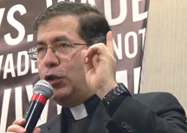
Do you have questions about abortion and how you can help to stop it, the pro-life movement and Priests for Life? At Priests for Life, we get lots of mail and questions about these topics, and now you can see answers to the most common questions on our website. At ProLifeQuestions.com, you can set up a free account, that will allow you to access our library of questions and answers at any time. You will find not only general pro-life questions but also medical questions submitted to our team of medical consultants. You will be able to select questions from the list or do a keyword search to find questions on a specific topic. And feel free to submit your own questions at any time or any question you would like to see in the library that you feel would be important to others. So, go to ProLifeQuestions.com and become a member of the community...it's easy!
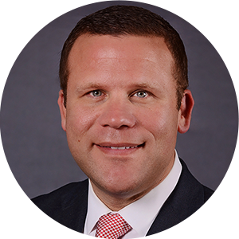
Sending aborted fetal remains to landfills: Ohio Right to Life called on the Ohio Department of Health to investigate how Ohio's abortion facilities' dispose of aborted fetal remains. This follows Attorney General Mike DeWine's investigation which revealed Planned Parenthood to be sending aborted fetal remains to landfills. The Attorney General argues that this is in violation of Ohio Administrative Code (3701-47-05) which requires that aborted fetal remains be disposed humanely. "In 2014, 21,186 abortions were carried out in Ohio," said Mike Gonidakis, president of Ohio Right to Life. "Sadly, when children are being aborted in droves, we have every reason to believe that the abortion industry is going to seek the most convenient route to dispose of their bodies. Aside from Planned Parenthood, many other abortion facilities could be disposing of aborted children in the same heartbreaking manner.""This is both a matter of public health and moral character," said Gonidakis. "The pre-born bodies of Ohio’s children do not belong in our trash, and landfills should not function as their mass unmarked graves. These children are individuals with their own intrinsic dignity. Along with salvaging their remains, Ohio Right to Life is intent on salvaging their dignity along with the truth." (http://www.ohiolife.org/)
“God… from my mother’s womb had set me apart and called me through his grace” (St. Paul to the Galatians 1:15)
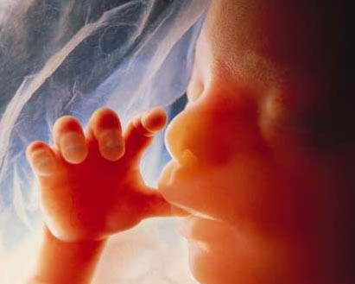
Learn More About Wyandot County Right To Life:
Our website: http://wyandotcountyrightolife.org/
(Note: right and to share a “t”) We have had 17,777views of our website as of 15 December 2015. Check us out!

Three things Christmas tells us about human life and dignity By Paul Stark, Communications Associate for Minnesota Citizens Concerned for Life

Christians use the Christmas holiday to remember and celebrate the birth of Jesus Christ. This event (apart from everything else it entails) provides a number of insights about human life and dignity. Here are three.
- Each of us was once an unborn child. The Incarnation—the coming into the world of Christ—did not happen in the manger. It happened some nine months earlier. This is what the facts of human embryology and developmental biology tell us, and it is what the scriptural accounts affirm.
Mary is said to be “with child” (Matthew 1:18) upon Jesus being “conceived … from the Holy Spirit” (Matthew 1:20). Earlier, Mary is told she will “conceive in [her] womb … a son, [to be named] Jesus” (Luke 1:31), who even before birth is called a “child … [who] will be called holy—the Son of God” (Luke 1:35). Luke 1:41-44 recounts that the unborn John the Baptist (who was probably in his sixth month) “leaped for joy” in his mother’s womb when he entered the presence of the unborn Jesus (who was probably a very young embryo at the time). Jesus began his earthly existence as an embryo and fetus. So did all of us.
2. The weak and vulnerable matter just as much as the strong and independent. God himself chose to enter the world in the most vulnerable condition possible: as a tiny embryo, and then a fetus, and then a newborn baby lying in a manger. This turned ancient “might makes right” morality on its head. It suggests that human dignity is not determined by age, size, power or independence.
3. Human life is extraordinarily valuable. Christmas is part of God’s larger plan to rescue humanity because He loves us (John 3:16). Jesus was born so that we might live. From this Christian perspective, God considers human life to be immensely precious and worth saving at tremendous cost. “Christian belief in the Incarnation is thus inseparable from belief in the objective, and even transcendent, value of the human race as a whole, and of each human person as an individual,” writes Carson Holloway (Source: National Right To Life Today,
December 11, 2015)
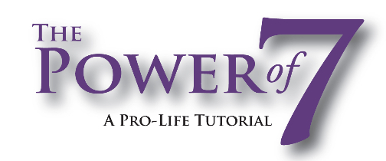
"The Power of 7 mobile app is a simple, effective tool for young pro-lifers. I recommend downloading this free app and speaking up for those who don't yet have a voice." - Larry Cirignano, Director, Children First Foundation of DC (Choose Life License Plates). Check out: http://audiogirlministries.com/
CDC 2012 report doesn’t include California, Maryland and New Hampshire. Better estimates still have the United States killing as many as 1,000,000 babies a year in abortions. That equates to over 83,000 every month, 19,230 a week and over 2,700 every single day. (Source: LifeNews.com, P.O. Box 270841 Fort Collins, CO 80527). Pray to stop the need for abortion! A true abortion – in which the direct intention is to end the life of a human being – is not a treatment for any type of maternal health risk. http://www.lifenews.com/2013/10/11/is-abortion-ever-necessary-to-save-the-life-of-the-mother/

Wyandot County Right to Life
Non Profit
U.S. Postage
Paid
Marion, OH
Permit # 23
P.O. Box 381
Upper Sandusky, OH 43351-0381
RETURN SERVICE REQUESTED

What Can I Do? 

- Pray for Respect for Human Life in our country and in the world. VOTE Pro-Life!
- Become a member of Wyandot County Right to Life ($6 dues donation)
- Work for Life – May we call you with volunteer opportunities? Yes PH_____________
- Support Wyandot County Right to Life with your gift of $________________________
If you choose your gift may be made
In Memory of (name) _______________________________________________________
Mailing Address____________________________________________________________
Or for a birthday, anniversary or special event
In Honor of (name) _________________________________________________________
Mailing Address____________________________________________________________
~~~~~~~~~~~~~~~~~~~~~~~~~~~~~~~~~~~~~~~~~~~~~~~~~~~~~~~~~~~~~~~~~~~~
**We regret that the federal government does not allow contributions to Wyandot County Right to Life to be tax deductible. If you would like your gift to be tax deductible, please make your check out to: Ohio Right to Life Educational Fund and in the
MEMO box mark for the use of: Wyandot Co Right to Life!!!! We will be able to use these funds for educational activities and you will have a tax deduction! Your gift is important to us. We are all volunteers, so every penny goes toward our mission of respecting and protecting human life from conception til natural death. Please mail to: Wyandot Co Right to Life P O Box 381 Upper Sandusky, OH 43351-0381. Thanks & God Bless You!!!

