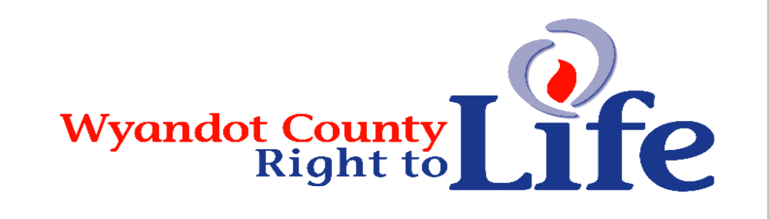

Wheat & Chaff Newsletter – Fall 2015

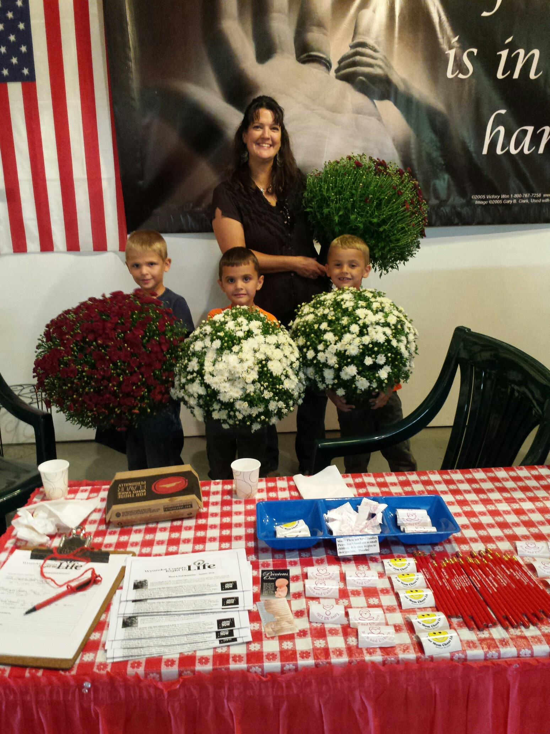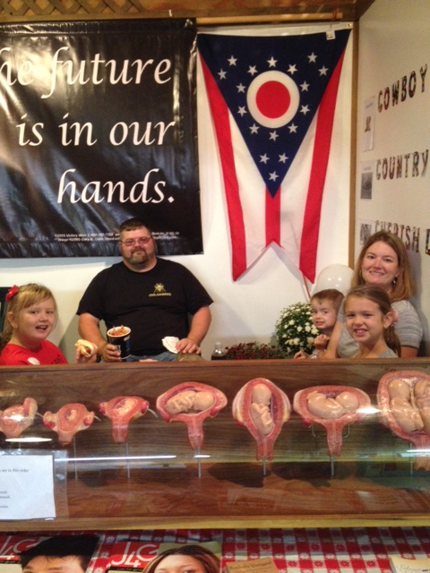

Wyandot Co Right to Life’s “LIFE” booth at the Wyandot Co Fair. Thanks to everyone who made the fair a success for LIFE. Your witness to the belief that all human life is sacred is more powerful than we can ever know!!! The winners of the DVD’s were: Isabella Brodman (4 yrs old), Carey - Veggie Tales, Sue Gault, Forest - A Mile in His Shoes and Bryan Davis, Kenton - October Baby. Thanks to our “rose” lady for the beautiful roses we were able to give to whomever the spirit led us to share them with. Thanks to the Upper and the Carey K of C for covering the expense of the booth rental. Thanks to each of you day leaders for contacting staffers for the booth each day. Thank you to each of you who gave of your time to staff the LIFE booth!

"Planned Parenthood's ongoing scandal continues to alienate the abortion provider from the American public. As reasonable Americans, pro-life and pro-choice alike, question the integrity of the abortion industry leader, it's more important than ever before that our leaders show us a way forward towards a society that safeguards every human person's right to life." Stephanie Ranade Krider, executive director of Ohio Right to Life

"As the ground shifts in the abortion debate, it is critical that we take a stand, articulating our position with the utmost compassion. Abortion advocates are losing for a reason: Profiteering on baby hearts, livers, and lungs simply cannot be tolerated--let alone stomached--by the American people." Stephanie Ranade Krider, executive director of Ohio Right to Life
“…the U.S. Senate failed to pass a law that would have prevented most abortions after babies are old enough to feel pain. It should sicken every American that our elected leaders have refused to protect our most vulnerable, even when science tells us these children can feel the intense pain of the abortionists’ tools tearing their arms and legs from their bodies.
Even more appalling is the abortion lobby's glitzy marketing efforts designed to cover up the trauma and grief of post-abortive women wounded by Planned Parenthood. Just this week, the abortion business encouraged women to flaunt their abortions on social media with the hashtag: #ShoutYourAbortion. The euphemisms of Big Abortion, however, cannot hide the barbaric, horrific practice of tearing children limb from torso, and poisoning to death five-month, seven-month and even eight-month-old babies in the womb.” Lila Rose, President, Live Action

DID YOU KNOW: Planned Parenthood does NOT do mammograms. Out of the 8,000+ facilities in the United States doing mammograms, ZERO of them are operated by PP. Nada. Big, fat, goose egg. If you do not believe me, just do a little research with the U.S. Food and Drug Administration. They keep a list of every licensed mammogram facility in the country. Maria Cahill, Former Miss America contestant: Women don’t need Planned Parenthood, https://www.lifesitenews.com/opinion/former-miss-america-contestant-women-dont-need-planned-parenthood?utm_source=LifeSiteNews.com+Daily+Newsletter)

Falsehood“…if we don’t give that funding to Planned Parenthood, those women will be out of health care for reproductive causes.” I wonder what the staff at the over 9,000 community health centers nationwide have to say about this. These centers provide all the services to women that Planned Parenthood claims to offer (other than abortion, but PP rarely claims that publicly). If we paid any attention to the Senate’s recent bill to defund Planned Parenthood, we would know that the monies (Almost half a billion tax dollars, by the way. Yes, you read that correctly. Half a billion.) would have been redirected to these locations. Maria Cahill, Former Miss America contestant: Women don’t need Planned Parenthood, https://www.lifesitenews.com/opinion/former-miss-america-contestant-women-dont-need-planned-parenthood?utm_source=LifeSiteNews.com+Daily+Newsletter)

Majority of U.S. Senate votes to advance Pain-Capable Child Protection Act, but Democrats block consideration.
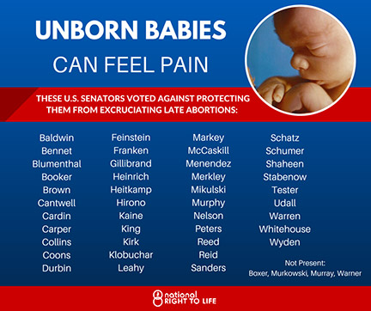
WASHINGTON – A majority of the U.S. Senate today voted to advance the Pain-Capable Unborn Child Protection Act (H.R. 36), but on a near party-line vote, a minority blocked consideration of the bill. Fifty-four (54) senators (51 Republicans and three Democrats) voted to take the bill up for debate, but 60 votes were required. The motion was opposed by 42 senators (two Republicans and 40 Democrats), with four senators absent (one Republican and three Democrats). National Right to Life President Carol Tobias said, “Today’s majority vote is not a defeat, but a stepping stone towards victory. One-fourth of premature infants now survive when born at this stage – and there is strong evidence that they experience great pain, as they are torn limb from limb in late abortions.” Some of the extensive evidence that unborn children have the capacity to experience pain, at least by 20 weeks fetal age, is available on the National Right to Life website at www.nrlc.org/abortion/fetalpain and also here: www.doctorsonfetalpain.com.(http://www.nationalrighttolifenews.org/news/2015/09/majority-of-u-s-senate-votes-to-advance-pain-capable-child-protection-act-but-democrats-block-consideration)
Former "Cover Girl" model and actress, Jennifer O'Neill, can testify to the pain. She says, "I had the abortion and paid for it all my life."
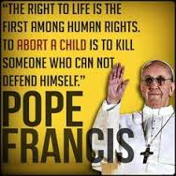
“Among the vulnerable for whom the church wishes to care with particular love and concern are unborn children, the most defenseless and innocent among us. Nowadays efforts are made to deny them their human dignity and to do with them whatever one pleases, taking their lives and passing laws preventing anyone from standing in the way of this.…Precisely because this involves the internal consistency of our message about the value of the human person, the church cannot be expected to change her position on this question… It is not ‘progressive’ to try to resolve problems by eliminating a human life…” — Pope Francis’ Apostolic Exhortation Evangelii Gaudium #213-214
A Public Square Rosary Rally will take place on the St. Mary Delaware front lawn on Saturday,
October 10 at Noon. It will take about 30 minutes. The purpose of the Rosary Rally is to fervently pray for the conversion of the United States, and to offer reparation for the sins and offenses committed against the Immaculate Heart of Mary and the Sacred Heart of Jesus. This Rosary Rally is one of over 13,000 Rosary Rallies which will take place all across America at noon on October 10. All are sponsored by America Needs Fatima. Please join us! If you can't make it, but you will still be willing to pray at noon on 10/10, please let me know and I will add you to our count. My cell is 314-572-5834 annette_sch@insight.rr.com. *Any and all faiths needed to pray for our beloved country and the entire world to protect us from the forces of evil!!!
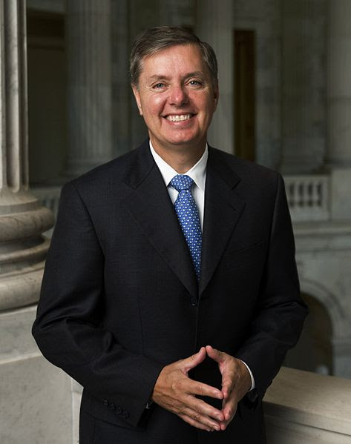
“America is at her best when she’s standing up for the least among us. “Even though we were not successful, this vote marks an important milestone when it comes to protecting the unborn. We took the first vote in the Senate and were able to see where every Senator stands. Today, the battle begins working to bring more supporters to our cause. “There are only seven countries that allow wholesale abortions at the 20-week period including China and North Korea,” said Graham. “We should no longer be part of that club.” At the age of 20 weeks or five months post-fertilization, scientific evidence tells us an unborn child can feel pain. Pain medication is administered directly to the unborn child in second-trimester fetal surgery, in addition to anesthesia. The unborn child shows physical, chemical, brain and stress responses demonstrating pain at this stage of development. The Pain-Capable Unborn Child Protection Act is based on science, has overwhelming public support, and is necessary to protect unborn children from painful, and untimely deaths.” Sen. Lindsey Graham (R-SC). *Consider the very commonsensical parameters of the Pain-Capable Unborn Child Protection Act. It extends general protection to unborn children who are at least 20 weeks beyond fertilization (which is equivalent to 22 weeks of pregnancy — about the start of the sixth month). Note: 42 United States senators—40 Democrats and two Republicans—voted against advancing the Pain-Capable Unborn Child Protection Act.

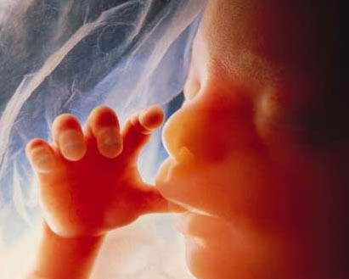

Learn More About Wyandot County Right To Life:
Our website: http://wyandotcountyrightolife.org/
(Note: right and to share a “t”)
We have had 17,189 views of our website as of 24 September 2015. Check us out!
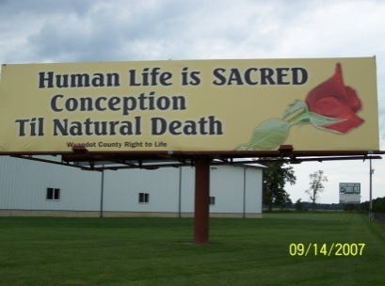
Wyandot County Right to Life
Non Profit
U.S. Postage
Paid
Marion, OH
Permit # 23
P.O. Box 381
Upper Sandusky, OH 43351-0381
RETURN SERVICE REQUESTED

What Can I Do? 

- Pray for Respect for Human Life in our country and in the world. VOTE Pro-Life!
- Become a member of Wyandot County Right to Life ($6 dues donation)
- Work for Life – May we call you with volunteer opportunities? Yes PH_____________
- Support Wyandot County Right to Life with your gift of $________________________
If you choose your gift may be made
In Memory of (name) _______________________________________________________
Mailing Address____________________________________________________________
Or for a birthday, anniversary or special event
In Honor of (name) _________________________________________________________
Mailing Address____________________________________________________________
~~~~~~~~~~~~~~~~~~~~~~~~~~~~~~~~~~~~~~~~~~~~~~~~~~~~~~~~~~~~~~~~~~~~
**We regret that the federal government does not allow contributions to Wyandot County Right to Life to be tax deductible. If you would like your gift to be tax deductible, please make your check out to: Ohio Right to Life Educational Fund and in the
MEMO box mark for the use of: Wyandot Co Right to Life!!!! We will be able to use these funds for educational activities and you will have a tax deduction! Your gift is important to us. We are all volunteers, so every penny goes toward our mission of respecting and protecting human life from conception til natural death. Please mail to: Wyandot Co Right to Life P O Box 381 Upper Sandusky, OH 43351-0381. Thanks & God Bless You!!!

