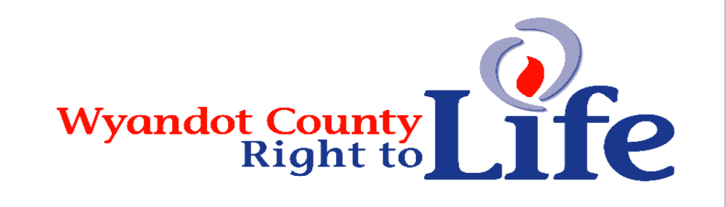

Wheat & Chaff Newsletter – June 2014



Thanks to everyone who purchased the LIFE geraniums this year! Hopefully yours are doing great! Seems to be a great year for geraniums ~ the leaves are large and especially pretty along with the blooms! Thanks to everyone who sold or purchased the Mother’s Day Red Carnations also! These are Wyandot Co Right to Life’s fundraisers for the year.

2014 Ohio Right to Life Sweepstake Tickets are enclosed. The tickets are $1 per ticket or $10 per sheet (12 tickets). Wyandot County Right to Life will receive 40% of any tickets that are sold through our chapter! There are ten total prizes: Grand Prize: (1) $1,000 (Bonus prize of $250 will be awarded to our chapter if you buy the grand prize ticket!). Second Place: (2) $500. Third Place (3): $250. Fourth Place: (4) $50.00. Feel free to make copies if you wish to purchase more than one page of tickets! The drawing will be held on Friday, Nov 7, 2014. Please return the ticket stubs and your donation money no later than October 15th (do it right away so you don’t forget ) to: Wyandot Co Right to Life P.O. Box 381 Upper Sandusky, OH 43351-0381. Thanks and wishing you good fortune!


Wyandot County Fair LIFE booth. Hopefully you and your church will help staff the LIFE booth this year. Call our wonderful day leaders and volunteer! Tuesday: Deb Rall; Wednesday: Doris Daniel; Thursday: Jean Ann Hoepf; Friday: Marie Frey; Saturday: Community Christian; Sunday: Bethel Ministries. The booth needs staffed from 10 am until 9 pm Monday through Saturday. Sunday the booth needs staffed 1-6 pm. The fair’s theme this year is “Let The Good Times Grow.” We look forward to seeing all of you this year! Come and enjoy visiting with your friends and promote LIFE! The Wyandot County Fair this year is Tuesday, September 9 through Sunday, September 14.

Thanks to everyone who has supported LIFE by becoming a member of Wyandot Co Right to Life! It’s not too late to show your support for the dignity of all human life from conception til natural death by becoming a member of Wyandot Co Right to Life through your 2014 membership donation. Send your $6 (or anything more ) donation to Wyandot County Right to Life, P.O. Box 381 Upper Sandusky, OH 43351-0381.




Survey: 80% of dads say media portrayals of fatherhood wrong. Well this is a pleasant surprise: the media incorrectly depict fathers, according to today’s dads – and, for once, the media agree. Just in time for Father’s Day, soap brand Dove hired Edelman Berland to survey 1,000 dads for Dove Men+Care. The dads challenged the media’s representation of fathers – with 80 percent agreeing the media fail to portray fathers' roles accurately. When asked what attributes describe fathers in the media, dads most frequently responded with "disconnected, bumbling and incompetent.” In regards to the media, Dove explained, “Three quarters of dads say they are responsible for their child’s emotional well-being, while only 20% of dads see this role reflected in media.” Other findings included: “Dads today are caring for their children's emotional well-being (74%) and taking responsibility for their daily needs (51%).”The company concluded, “It’s time to acknowledge the caring moments of fatherhood that often go overlooked.” (Source: “Survey: 80% of Dad’s say media portrayals of fatherhood wrong” by Kathryn Yoder, http://www.lifesitenews.com/blog/survey-80-of-dads-say-media-portrayals-of-fatherhood-wrong?)

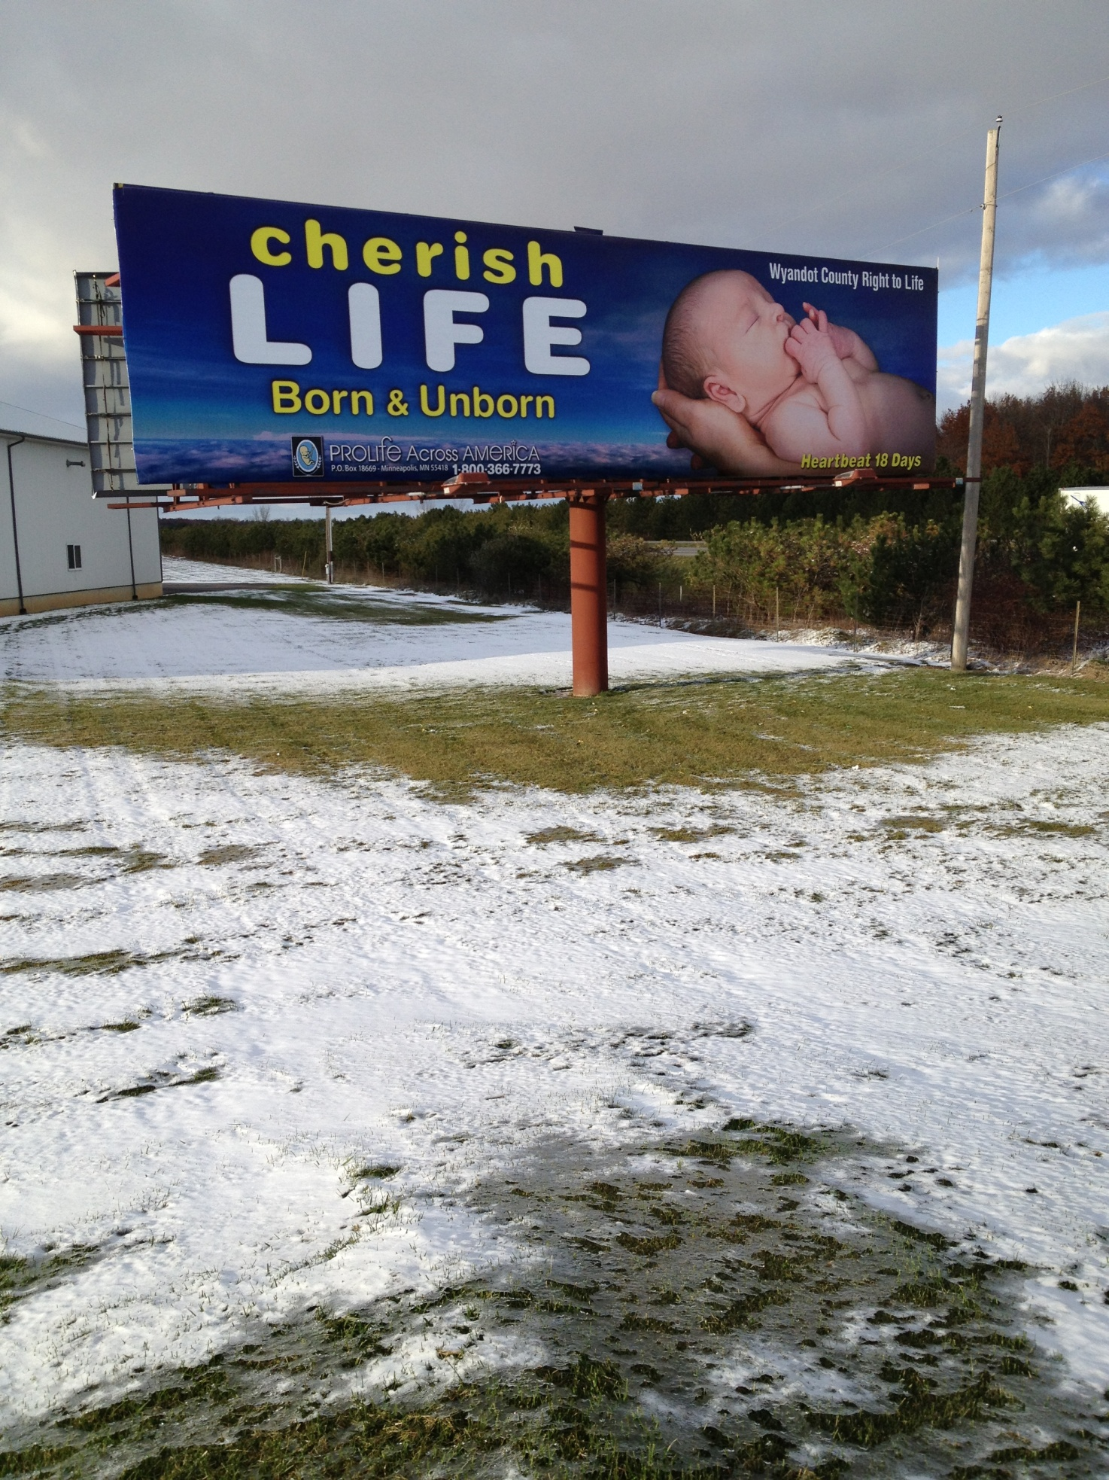
Wyandot County Right To Life’s billboard on the U.S. 23/15 bypass. We hope you’ve gotten to see this billboard and that it is being noted by travelers heading north.

“A good father is one of the most unsung, unpraised, unnoticed, and yet one of the most valuable assets in our society.” Billy Graham

Learn More About
Wyandot County Right To Life:
Our website:
http://wyandotcountyrightolife.org/ (Note: right and to share a “t”)
Our Facebook page:
https://www.facebook.com/WyandotCountyRightToLife
We hope you hit “Like”

“Human Life is Sacred… Conception Til Natural Death”

Did you know that Planned Parenthood casts itself as a leading sex educator of children? Or that PP receives government funds – your tax dollars – to teach your kids, or your neighbors' kids, about dangerous and violent sexual practices? In Indiana, a Planned Parenthood counselor encouraged a girl who she thought was 15 years old to explore bondage, domination, and sadomasochism. "You could be a dominatrix-type of person," she says, "where you dress in all leather, with the whips and the handcuffs." She continued, "It just depends what type of pain you can take." With millions from ObamaCare going to "sex education" initiatives – and with Planned Parenthood at the front of the line for those funds – Live Action decided to find out what this abortion corporation is teaching our kids. As hard as this is to watch, we need to know the truth about Planned Parenthood’s dangerous sexual agenda for our nation’s children. In addition to killing over 320,000 children a year, Planned Parenthood is planning a different kind of destruction for our born children. Go to PlannedParenthoodExposed.com to learn more, and to receive up-to-date news on our breaking videos. (Source: Lila Rose, Live Action, info@liveaction.org)
“Nothing changes the objective reality: abortion kills babies in their mothers’ wombs. Abortion is not merely the removal of some tissue from a woman's body. Abortion is not the removal of a living ‘thing’ that would become human if it were allowed to remain inside the woman’s body. Abortion is the destruction of an unborn baby. Pregnancy is the period for this new human life to mature, not to ‘become human’ — it already is. This is why the Church considers abortion the killing of a human being, and why the Second Vatican Council called it an ‘unspeakable crime’.”
- John Cardinal O’Connor

“…abortion does not forever change the destinies of women and unborn children alone, but husbands, boyfriends, brothers, grandfathers, even uncles and cousins. If you think the latter is a stretch, I can tell you from personal experience what a difference my father’s care and compassion for my unwed, pregnant cousin made in her decision to carry her baby to term and to find a loving is pregnancy.” Dave Andrusko

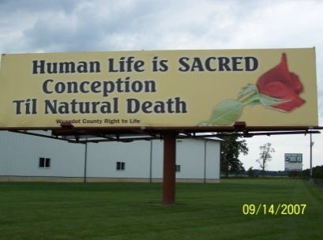Wyandot County Right to Life
Non Profit
U.S. Postage
Paid
Marion, OH
Permit # 23
P.O. Box 381
Upper Sandusky, OH 43351-0381
RETURN SERVICE REQUESTED

What Can I Do?
- Pray for Respect for Human Life in our country and in the world.
- Become a member of Wyandot County Right to Life ($6 dues donation)
- Work for Life – May we call you with volunteer opportunities? Yes PH_____________
- Support Wyandot County Right to Life with your gift of $________________________
If you choose your gift may be made
In Memory of (name)________________________________________________________
Mailing Address______________________________________________________
Or for a birthday, anniversary or special event
In Honor of (name)_________________________________________________________
Mailing Address______________________________________________________
We regret that the federal government does not allow contributions to Wyandot County Right to Life to be tax deductible. If you would like your gift to be tax deductible, please make your check out to: Ohio Right to Life Educational Fund. We will be able to use these funds for educational activities and you will have a tax deduction! Your gift is important to us. We are all volunteers, so every penny goes toward our mission of respecting and protecting human life from conception til natural death. Please mail to: Wyandot Co Right to Life P O Box 381 Upper Sandusky, OH 43351-0381. Thanks & God Bless You!!!

