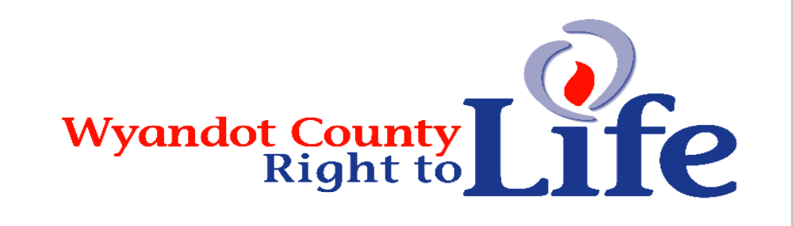

Wheat & Chaff Newsletter – Dec 2013

Envelopes are enclosed for your Jan 1 through Dec 31, 2014 dues. Thank you & God Bless! We are all volunteers so your donation goes to promote the sacredness of human LIFE!

Check for our Jan 22 Pro-Life ad in the Daily Chief Union & the Progressor Times-Mohawk Leader papers.

My Broken Cup: Finding Hope and Healing on the Anniversary of My Abortion by Beatrice Fedor | Washington, DC | LifeNews.com | 12/20/13 (http://www.lifenews.com/2013/12/20/my-broken-cup-finding-hope-and-healing-on-the-anniversary-of-my-abortion/)
Today December 20th is the 13th anniversary of my second abortion. In January, it will be the 20thanniversary of my first abortion. This morning, my two year old son broke my “Mom” coffee cup. It reminds me that abortion broke my mother’s heart all those years ago. Two little shards broke off from the cup, just where I put my lips; a reminder of all the kisses I never gave my two children lost to abortion. Rest in peace Alicia and Gabriel, you will never be forgotten. Mom loves you and fights the scourge of abortion in your memory now. My cup has been broken but it is filled with blessings. I am reconciled with God and with myself, I have been married eight years to a wonderful man and last month, I gave birth to our fourth child (I’m nursing her while writing this post). I don’t want to throw my Mom cup away. It is broken but it wasn’t shattered in a thousand pieces. It is possible to mend it, just like my broken heart was mended. I wish all women who had an abortion (even the hardest, rationalizing Pro-Choicer) could feel that hope, that as long as they are beating, our hearts can be mended and filled anew with the blessings of motherhood.

The greatest destroyer of peace is abortion because if a mother can kill her own child, what is left for me to kill you and you to kill me? There is nothing between.Mother Teresa

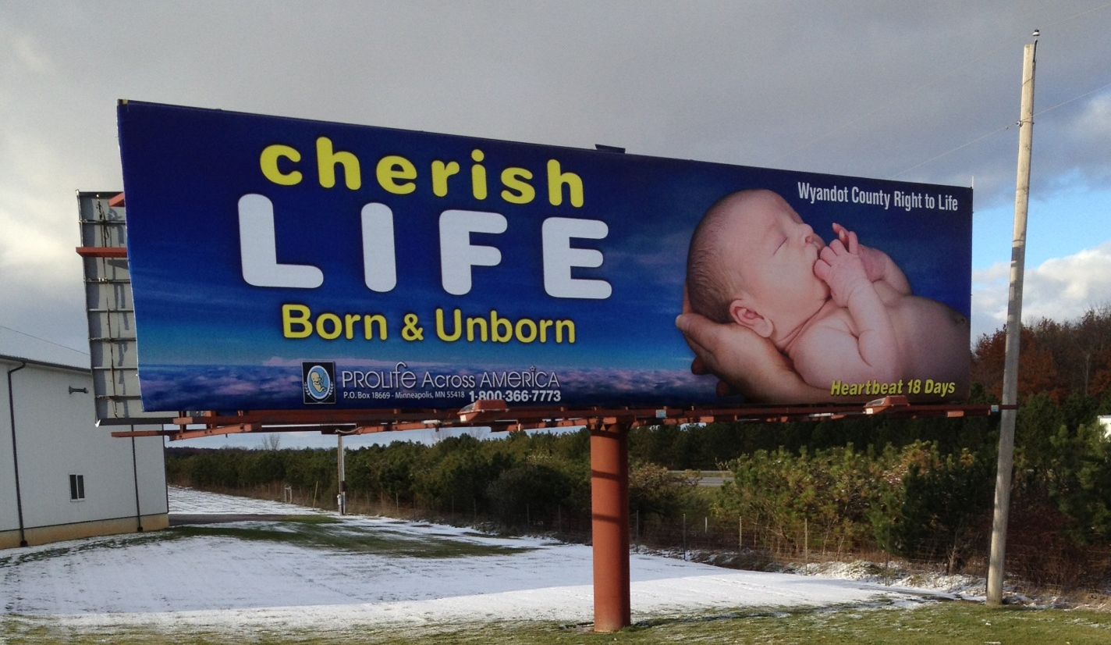
Announcing Wyandot County Right To Life’s new billboard on the U.S. 23/15 bypass. Our original one still had our “Human Life Is Sacred…Conception til Natural Death but the yellow had long since faded to white. We hope this billboard will be as noticeable to travelers heading north.

Joseph a Righteous Man ~ In Matthew’s Gospel we hear the story of the annunciation from
Joseph’s perspective. We do not look to Joseph very frequently, but he had to be a man of incredible faith. The Gospel doesn’t exactly tell us how Joseph got the word that Mary was pregnant, but we can only imagine the heartbreak and disappointment he must have felt at first. We get a glimpse of his character when Matthew tells us that he didn’t want to expose Mary to shame (she would have been stoned to death on her father’s door step!) so he was going to divorce her quietly. The angel appears to Joseph in a dream to explain the unexplainable: Mary’s child was conceived through the Holy Spirit. What faith it must have taken to believe that dream and that he was chosen to fulfill a great role in the coming of the Messiah, Emmanuel. Then quite simply, the Gospel says that Joseph awoke and did as the Lord’s angel had commanded him. He brought Mary into his home. Even today’s unwed mother’s need our support and encouragement to give their babies the gift of LIFE.

Pro-Life Victory: A Record 87 Abortion Clinics Closed in 2013. Operation Rescue has concluded an exhaustive survey of abortion clinics in the U.S. and is pleased to announce that it has documented a record number of abortion clinic closures in 2013, during which time 87 surgical abortion clinics halted abortions. (Read More: by Cheryl Sullenger, http://www.lifenews.com/2013/12/23/a-record-87-surgical-abortion-clinics-close-in-2013)

Learn More About
Wyandot County Right To Life:
Our website:
http://wyandotcountyrightolife.org/ (Note: right and to share a “t”)
Our Facebook page:
https://www.facebook.com/WyandotCountyRightToLife
We hope you hit “Like”

“Human Life is Sacred… Conception Til Natural Death”

The numbers don’t lie: Babies are blessings for everyone - $217,000 happens to be the net financial benefit to society if you become a parent, according to a recent study by Lee et al. Lee et al decided to crunch the numbers and see if parenthood benefited society or not. They asked the question: “By the end of his or her life, does becoming a parent contribute more to the public than it takes away?” The researchers calculated that childless individuals added $328,000 to the common good over their lifetime, whereas a parent adds a whopping $545,000. So society receives $217,000 in benefits when an individual decides to become a parent. Anticipating criticism from the environmentalists, the authors even tried to calculate the “environmental costs” of childbearing. At PRI, we are generally suspicious of “greenhouse costs per person,” since we believe the net impact of global warming—if it occurs—is not man-made. Still, they concluded that childbearing remains a net positive to society even after deducting such “costs.” The “value” of selflessly giving oneself to another person who is completely dependent upon you far defies calculation. The most that economists can do is measure the side effects of such sacrificial love, such as increased motivation or increased investment in the future. Because sacrificial love is such a precious commodity, even its side effects are valuable—to the tune of $217,000. (Read more: BY STEVEN W. MOSHER AND ANNE ROBACK MORSE, (Population Research Institute), http://www.lifesitenews.com/news/the-numbers-dont-lie-babies-are-blessings-for-everyone)

Planned Parenthood and America’s war on babies ~ It’s odd that there seems to be this need, even from self-proclaimed pro-lifers, to portray Planned Parenthood as a good organization, aside from the abortions. Live Action’s investigations have shown otherwise time and time again, as Planned Parenthood has been caught giving inaccurate medical information, using manipulative counseling to coerce women into getting abortions, covering up sexual trafficking and statutory rape, and even willingly carrying out race-and-sex-based abortions. Meanwhile, 94% of babies whose mothers take them into Planned Parenthood won’t end up coming out alive. Planned Parenthood is waging a war on babies for sure, but they aren’t doing so alone. Remember, they’re receiving half a billion dollars in taxpayer funding, so we can’t really call this Planned Parenthood’s war on babies. No, it’s much worse than that. With our money and complicity, this isn’t just their war. It’s America’s war on babies, too. (Read More: by Cassy Fiano, http://liveactionnews.org/planned-parenthood-and-americas-war-on-babies/)

January 22, 1973 is ingrained in the minds of pro-lifers because on that infamous historic day the Supreme Court invalidated 50 state laws and made abortion legal and available on demand throughout the United States in the now-infamous decisions in Roe v Wade and Doe v Bolton.

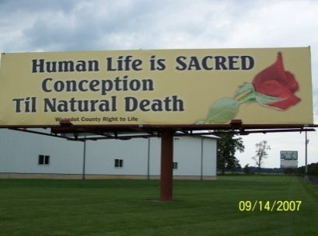
Wyandot County Right to Life
Non Profit
U.S. Postage
Paid
Marion, OH
Permit # 23
P.O. Box 381
Upper Sandusky, OH 43351-0381
RETURN SERVICE REQUESTED

What Can I Do?
- Pray for Respect for Human Life in our country and in the world.
- Become a member of Wyandot County Right to Life ($6 dues donation)
- Work for Life – May we call you with volunteer opportunities? Yes PH_____________
- Support Wyandot County Right to Life with your gift of $________________________
If you choose your gift may be made
In Memory of (name)________________________________________________________
Mailing Address______________________________________________________
Or for a birthday, anniversary or special event
In Honor of (name)_________________________________________________________
Mailing Address______________________________________________________
We regret that the federal government does not allow contributions to Wyandot County Right to Life to be tax deductible. If you would like your gift to be tax deductible, please make your check out to: Ohio Right to Life Educational Fund. We will be able to use these funds for educational activities and you will have a tax deduction! Your gift is important to us. We are all volunteers, so every penny goes toward our mission of respecting and protecting human life from conception til natural death. Please mail to: Wyandot Co Right to Life P O Box 381 Upper Sandusky, OH 43351-0381. Thanks & God Bless You!!!

