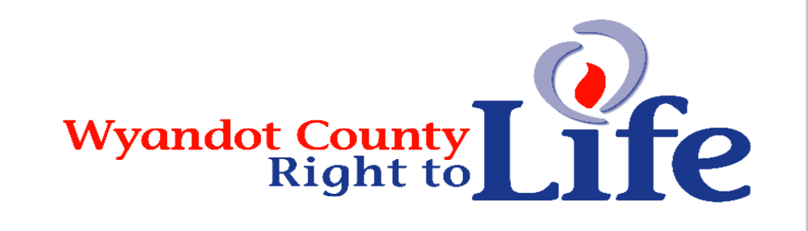

Wheat & Chaff Newsletter – Apr-May 2013

Remember to order your Wyandot Co Right to Life Geraniums by calling Mary @ 419-209-0406 (Cty Hwy 38 W), Jean Ann @ 419-396-3217 (St Hwy 103 E) or Megan Frey @ 419-294 1646 (Cty Hwy 97).

Thanks to everyone who supported LIFE through their membership donation to Wyandot County Right to Life!!! It is not too late to show your support for the sanctity of human life through your 2013 membership donation. Send your $6+ donation to Wyandot Co Right to Life PO Box 381 Upper Sandusky, OH 43351-0381. Thanks & God bless! We are all volunteers so donations go to the LIFE cause ~Human Life is Sacred from Conception til Natural Death. Your donations help pay for our 2 double billboards in Wyandot Co, the newspaper ads, promotion on WXML Christian Radio, the newsletters, upkeep of landscaping around Rachel Mourning in OLC Shrine Park, etc.

Did you know? 1 million of our Americans have been killed in every war we have fought since 1775 while 55.5 million of our children have been killed by abortion in the USA since 1973!! Is there any wonder our economy is lopsided with us as a land of elderly in need of care?

ABC, CBS, and NBC’s morning and evening newscasts have yet to cover the trial of Dr. Kermit Gosnell, which began on Monday. Gosnell is charged with murdering seven babies who were born after viability in his rundown abortion facility. The Big Three also gave the story minimal coverage back in January 2011, after the Philadelphia physician was arrested. ABC completely ignored it, CBS Evening News aired one full story, and NBC gave just 50 words on Today. Even the New York Times covered the trial in a Tuesday article, though it appeared on page A-17. Writer Jon Hurdle documented how Gosnell is charged with killing the babies by “plunging scissors into their necks and ‘snipping’ their spinal cords.” (http://www.lifenews.com/2013/03/20/big-three-networks-ignore-abortion-doc-who-snipped-babies-necks/)

“I ask that you continue to turn your Lenten prayers and acts of self-denial – especially your fasting and almsgiving – into the spiritual powerhouse we need to win our fight to end abortion-on-demand in America. I know God will look favorably upon your sacrifices and use them to bless our efforts. In these critical times when the heralds of the culture of death hold the reins of power in our government, Priests for Life is going to need you more than ever as we continue to preach the Gospel of Life and remind our fellow Americans that abortion corrupts our whole society and retards progress on all the other issues that concern them ... including the economy!”
(Fr. Frank Pavone National Director, Priests for Life and Gospel of Life Ministries)

For those of you who did not get to see our Jan 22 Pro-Life ad in the Daily Chief Union & The Progressor Times-Mohawk Leader papers it follows next:

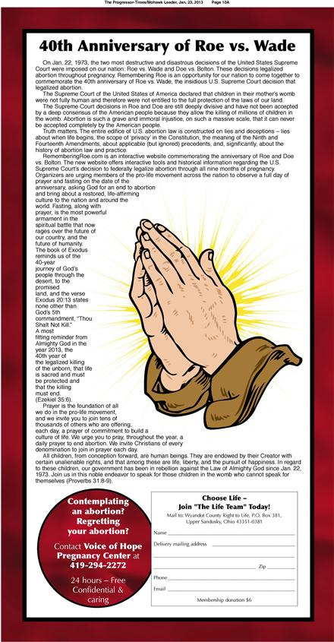

“Let us not lose heart in doing good, for in due time we will reap if we do not grow weary.” Galations 6:9.

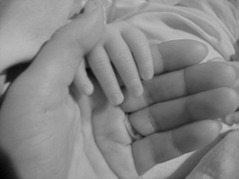
“Having recently celebrated Christmas, can any of us honestly imagine that the new life in Mary’s womb from the moment of the Annunciation was not the person of Christ the Lord in the flesh? Or that John the Baptist, who leaped for joy in the womb of his mother Elizabeth, was only a mass of tissue?” (Pro-life events mark 40th anniversary of Roe v. Wade, Bishop Leonard Blair, Diocese of Toledo, Catholic Chronicle, Feb 1, 2013)

Julie Revelant wrote an article that appeared in the Fox News health section: “How to plan for an unplanned pregnancy.” Her advice for women who find themselves pregnant – perhaps in spite of their own plans – is both timely and excellent. Kudos to Fox for printing it. First of all, don’t freak out. Stop staring at the blue plus sign and wipe the shocked look off your face. Whether you’re a first time mom or you’re adding more to your brood, you’ll get through this. Women throughout all of time have gotten through unplanned pregnancies where both they and their children come out – literally for the child – on the other side. Life is new and different and sometimes more difficult, but life with a new child is beautiful. Whether or not a child is “planned” has no effect on the beauty or worth of her life. Women before you have done this. Women after you will do it again. And today, you can do it, too. As Diane Lang states: Instead of thinking of it as an unplanned pregnancy or an accident, think of it as a gift. … Be open to what’s coming, because it is the unexpected – but the unexpected a lot of times brings a lot of greatness with it. (http://www.nationalrighttolifenews.org/news/2013/03/fox-news-how-to-plan-for-an-unplanned-pregnancy/#.UUxXAOSG3e5).

Bethel Pro-Life Ministries helpline is 1-800-712-4357. Bethel’s Walk for Life is Sat, May 4 call: 419-294-2273 for more information. Their goal $25, 000 for their 25th Year.

Abortion: Turn off taxpayer spigot for Planned Parenthood: Thomas Lucente asks: What would you say if I told you there is an organization funded by the government that was responsible for 333,964 deaths in 2011? According to the Planned Parenthood Federation of America’s 2011-12 annual report released Jan 7 (http://j.mp/USqMYT), that is the number of babies the agency killed in 2011, a record high. From 2009 to 2011, just a three-year span, Planned Parenthood abortionists killed almost 1 million babies (995,687). That is 1 million lives intentionally killed in a mere 36 months by one organization. That, my friends is not a “Choice”; that is massacre, a holocaust of those in our society least able to defend themselves. Abortions made up 92% of PP’s pregnancy services while prenatal care & adoption referrals accounted for only 7% & 0.6%. For every adoption referral, PP killed 145 babies. This year, they are mandating that all affiliates perform abortions, which means 2013 will be the bloodiest yet. (Thomas J Lucente Jr tlucente@limanews.com Jan 20, 2013).

Over the eight year period studied, women who aborted had a 446 percent higher risk of death from cerebrovascular disease. The overall death rate from natural causes was 44 percent higher for women who aborted. Elliot Institute director Dr. David Reardon, the lead author of the California study, said that while higher rates of death from suicides and accidents were most pronounced during the first four years after abortion, deaths from natural causes increased during the later years of the period studied. “This could reflect long term damage from problems such as depression and anxiety on women’s cardiovascular and immune systems,” Reardon said. “Depression is a known cause of heart disease.” (New Study: Abortion Can Lead to Risk of Heart Disease and Stroke by Amy Sobie, http://www.lifenews.com/2013/03/21/new-study-abortion-can-lead-to-risk-of-heart-disease-and-stroke/)


Wyandot County Right to Life
Non Profit
U.S. Postage
Paid
Marion, OH
Permit # 23
P.O. Box 381
Upper Sandusky, OH 43351-0381
RETURN SERVICE REQUESTED

*** Annual Right to Life Geranium Sale – will be Thurs May 2, Friday May 3 & Sat May 4. The geraniums will be delivered on Wed May 1 & we will call you as soon as they arrive so you can pick them up. The cost will be $2.00 per 3 plants, $12.00 per ½ flat of 18 plants and $23.00 per flat of 36 plants.

What Can I Do?
- Pray for Respect for Human Life in our country and in the world.
- Become a member of Wyandot County Right to Life ($6 dues donation)
- Work for Life – May we call you with volunteer opportunities? Yes PH_____________
- Support Wyandot County Right to Life with your gift of $________________________
If you choose your gift may be made
In Memory of (name)________________________________________________________
Mailing Address______________________________________________________
Or for a birthday, anniversary or special event
In Honor of (name)_________________________________________________________
Mailing Address______________________________________________________
We regret that the federal government does not allow contributions to Wyandot County Right to Life to be tax deductible. If you would like your gift to be tax deductible, please make your check out to: Ohio Right to Life Educational Fund. We will be able to use these funds for educational activities and you will have a tax deduction! Your gift is important to us. We are all volunteers, so every penny goes toward our mission of respecting and protecting human life from conception til natural death. Please mail to: Wyandot Co Right to Life P O Box 381 Upper Sandusky, OH 43351-0381. Thanks & God Bless You!!!

