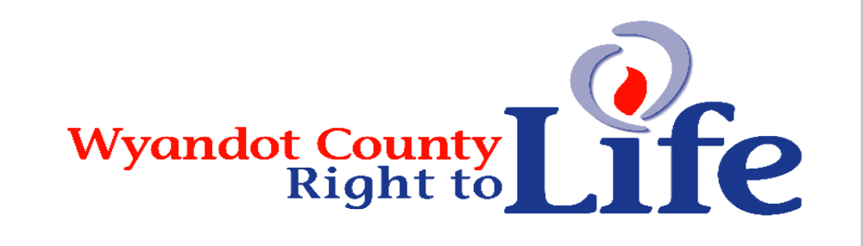

Wheat & Chaff Newsletter – Nov-Dec 2012

Jan 22 Commemorative Issue: 40 Years of Roe – 40 years too many! - Wyandot Co Right to Life is mailing to each of you on our mailing list a copy of National Right to Life’s
Special Issue. Watch for it’s arrival in your mail box in January!

Watch for our Jan 22 Ad in our local papers!

LIFE Sweepstakes raffle drawing winning tickets:

- ($1000) Mary Lou Guilbault, Saint Henry
  - ($250 prize to Mercer County Right to Life for selling the winning ticket!)
- ($500) Joanne Elchert, New Riegel
- ($500) J. Siebeneck, Doylestown
- ($250) Mr. & Mrs. John Kocevar, South Euclid
- ($250) Charles Koesters, Coldwater
- ($250) Urban Albers, Minster
- ($50) Margaret Eilerman, Minster
- ($50) Sherri Ross, Xenia
- ($50) Cynthia Dapore, Versailles
- ($50) Viola Bruns, Coldwater

Congratulations to all the winners! Thank you to all who purchased sweepstakes tickets, enabling us to continue our mission to promote and defend life! Our local chapter got 40% of the tickets sold through our chapter.

LIES - Obama had launched a war over abortion and on the Life issue, therefore he got to completely define what that issue was -- and what is it? Rape. Abortion meant rape in the minds of many voters because the debate was not fully engaged. The President's weaknesses -- his extreme positions on late term abortions, on sex-selective abortions, on not saving children born even after a failed abortion -- none of these weaknesses were exploited in any debate. Even the lies he put forth during the debates went unaddressed. The lie that Planned Parenthood doesn't perform abortions. The lie that Planned Parenthood does do mammograms. The lies that hospitals with religious tenets won't be forced to fund abortion inducing drugs and sterilizations. (Source: Moving forward, Susan B. Anthony List, President Marjorie Dannenfelser)

Now that the most pro-abortion president in U.S. history has managed to hold onto the White House, it’s time to shift our focus from national politics to effective, local grassroots pro-life activism. (Source: http://prolifeaction.org)
Focus on the Family supports efforts to offer women tangible alternatives to abortion. Women are certainly not the only ones affected by abortion. The preborn baby human at the center of the pregnancy has no choice, or voice, in the abortion decision yet, in most cases, arguably the most to lose. Biologically speaking, human life begins at the single cell stage (fertilization) when sperm and egg join. There is no doubt that this growing entity is fully human and a member of the human family. And that fact makes abortion a human rights issue. What human rights does the preborn baby possess? Focus on the Family and other pro-life organizations believe the right to life extends to these little ones. Human life — from fertilization to natural death — holds intrinsic and inestimable worth apart from how old you are and where you live. Abortion poses risks to women and kills their preborn children. At its root, abortion is evidence of a lack of choices for women in unintended pregnancies as well as a societal disrespect for the value of young human life.
(Source: http://www.focusonthefamily.com/socialissues/social-issues/abortion/cause-for-concern.aspx)

"My people perish for lack of knowledge"Hosea Chapter 4

The philosophy of the schoolroom in one generation will be the philosophy of government in the next. Attributed to President Abraham Lincoln

The sanctity of life is a simple truth that can and must be taught like any other subject in school. In Christian schools it should be the highest priority. Those who control schools, and especially Religious education need only the will to make this happen. Each day this does not happen is another day of victory for the pro-abortion forces, because ignorance of the masses is the only hope they have for survival. The culture of death is a supernatural evil that cannot be defeated simply by changing human laws. It will require teaching the fullness of the truth that comes from Jesus Christ regarding His immutable law on the sanctity of each human life. We must start with being mindful that young children are naturally Pro-Life. Ask a young child who has a pregnant mother what is inside his mother's “tummy,” and he will likely respond that it is his baby brother or sister. Christian educators must work with this incredible advantage: That students' minds are open vessels for learning about the sanctity of life-from conception to natural death. With this in mind we must consider the potential for a great shift to a culture of life if the millions of Christian school students across the nation were to receive a Pro-Life education lasting from K - 12th grade.
(Source: The Missing Key of the Pro-life Movement; http://www.cpforlife.org)

"Choose life, then, that you and your descendants may live." Dt 30:19

“Abortion and euthanasia are crimes, which no human law can claim to legitimize. There is no obligation in conscience to obey such laws; instead there is a grave and clear obligation to oppose them by conscientious objection. In the case of an intrinsically unjust law, such as a law permitting abortion or euthanasia, it is therefore never licit to obey it, or to `take part in a propaganda campaign in favor of such a law, or vote for it'” (Gospel of Life)

“Whatsoever you do to the least of these my brethren, you do to Me,” also applies in the voting booth. We are each, individually, called to help build a Culture of Life. Voting in defense of LIFE is among the most important ways. (Source: The Missing Key of the Pro-life Movement; http://www.cpforlife.org)

Train up a child in the way he should go even when he is old he will not depart from it.
Proverbs 22:6

“Life begins at conception – NOT birth. Birth is one day in the life of a PERSON who is already nine months old. (Source: The Missing Key of the Pro-life Movement; http://www.cpforlife.org)

“The attack on life doesn’t begin in the womb. It begins in the minds of people.” Ron Galloy
"The only foundation for a useful education in a republic is to be laid in religion. Without this there can be no virtue, and without virtue there can be no liberty, and liberty is the object and life of all republican governments." Benjamin Rush, Founding Father and signer of the Declaration of Independence

“Each time a person is aborted or euthanized and robbed of their rights, our rights and very lives become less secure.”

We challenge the leaders of the churches throughout America to be activly pro-life and teach your flocks. You can do this by beginning comprehensive Sanctity of Life education programs. This world is teaching them, even the youngest, to be pro-death. Indeed, each person will eventually choose a culture to which to belong. You are in the unique position to influence our youth so as to destroy the culture of death. (Source: Christian Patriots For Life, The Missing Key of the Pro-life Movement; http://www.cpforlife.org)

Abortion: The great contradiction to everything this Republic stands for.

"Never, never will we desist till we extinguish every trace of this bloody traffic, of which our posterity, looking back to the history of these enlightened times will scarce believe that it has been suffered to exist so long a disgrace and dishonor to this country"
(Source: William Wilberforce: Member of Parliament who led the fight for the abolition of slavery in Great Britain.)

“Remember to PRAY!!! Pray for everyone suffering in the aftermath of Hurricane Sandy. The destruction is far worse than I can describe. So many need so much help. But no one needs our help more than our unborn brothers and sisters. Homes and roads can be repaired. Businesses and subways can be rebuilt. But a life snuffed out in abortion can never be restored”.
(Source: Fr Frank Pavone, Priests for Life, PO Box 141172, Staten Island, NY 10314.)

End-of-life care is a difficult but necessary issue to discuss with your loved ones. Now, because of Obamacare, the need to address this topic is more urgent than ever. First, let me say that we should never refer to a human person as being in a “persistent vegetative state.” It’s insulting and dehumanizing to call people—regardless of their mental capabilities—vegetables. Now for the exciting news. A recent case in Canada has provided a scientific breakthrough that one of his doctors said would require the rewriting of medical textbooks. Further, it will affirm the rights of profoundly disabled patients and provide them with much better care. Scott Routley is a 39 year-old man who suffered a severe brain injury in a car accident 12 years ago. His doctors believed his physical assessments showed no signs of awareness or ability to communicate. Yet, his parents continued to state that they believed he was able to communicate by lifting a thumb or moving his eyes. This wasn’t enough to convince the medical staff. Thankfully, Scott benefited from a relatively new technology called fMRI. Magnetic resonance imaging (MRI), according to RadiologyInfo.org, uses a powerful magnetic field, radio frequency pulses and a computer to produce pictures of organs, soft tissues, bone and other internal parts of the body. Functional magnetic resonance imaging (fMRI) is a relatively new procedure that uses MR imaging to measure the tiny metabolic changes that take place in an active part of the brain. Scott’s brain activity was scanned via fMRI as he was asked a series of questions. The evidence showed his brain produced a pattern, clearly demonstrating that he was responsive. Neuroscientists said they were able to show that Scott has a conscious, thinking mind. One of the researchers said, “In the future we could ask what we could do to improve their quality of life. It could be simply things like the entertainment we provide or the times of day they are washed and fed.”
(Source: This breakthrough rewrites the medical textbooks, Bradley Mattes, Executive Director, Life Issues Institute, http://www.lifeissues.org/thelatestnews.html)

**Envelope enclosed for your Jan 1 thru Dec 31, 2013 Dues. Thank you & God Bless You!!!**
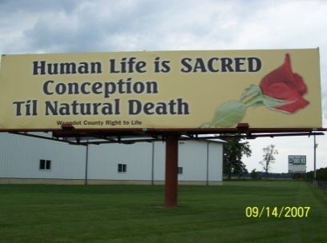
Wyandot County Right to Life
Non Profit
U.S. Postage
Paid
Marion, OH
Permit # 23
P.O. Box 381
Upper Sandusky, OH 43351-0381
RETURN SERVICE REQUESTED

Enclosed are envelopes for your Jan 1 – Dec 31, 2013 Dues. Thanks & God Bless!!!

What Can I Do?
- Pray for Respect for Human Life in our country and in the world.
- Become a member of Wyandot County Right to Life ($6 dues donation)
- Work for Life – May we call you with volunteer opportunities? Yes PH_____________
- Support Wyandot County Right to Life with your gift of $________________________
If you choose your gift may be made
In Memory of (name)________________________________________________________
Mailing Address______________________________________________________
Or for a birthday, anniversary or special event
In Honor of (name)_________________________________________________________
Mailing Address______________________________________________________
We regret that the federal government does not allow contributions to Wyandot County Right to Life to be tax deductible. If you would like your gift to be tax deductible, please make your check out to: Ohio Right to Life Educational Fund. We will be able to use these funds for educational activities and you will have a tax deduction! Your gift is important to us. We are all volunteers, so every penny goes toward our mission of respecting and protecting human life from conception til natural death. Please mail to: Wyandot Co Right to Life P O Box 381 Upper Sandusky, OH 43351-0381. Thanks & God Bless You!!!

