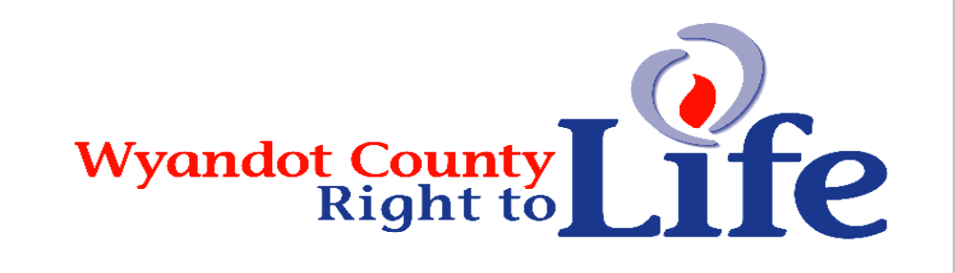

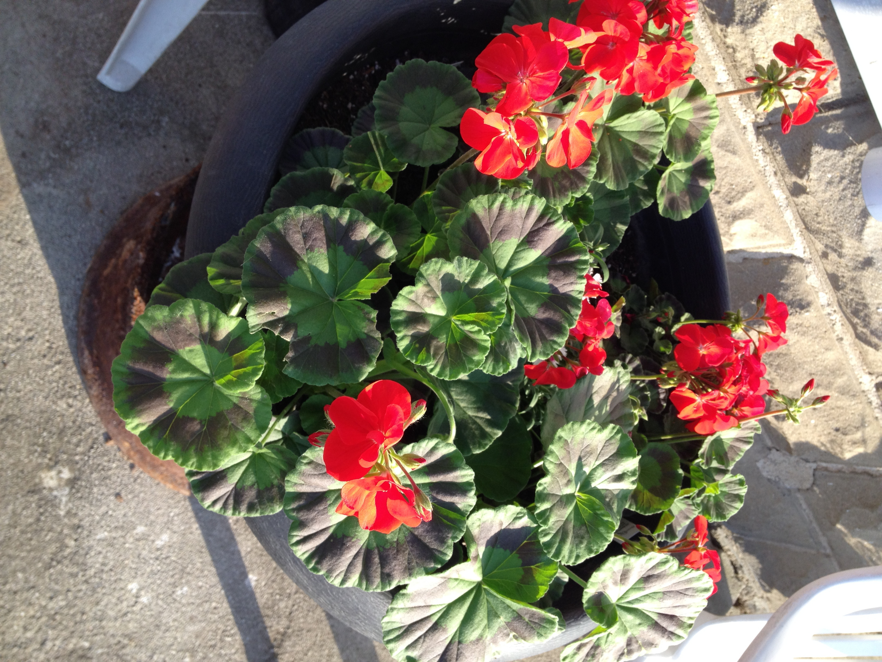
Wheat & Chaff Newsletter – Summer 2015

Annual Right to Life Geranium Sale – Hope your Red, Salmon, White, Violet & Pink Geraniums are as Gorgeous a show of color as ours! Thanks to all of you who help promote LIFE by purchasing the LIFE geraniums!!!


Thanks to everyone who has supported LIFE by becoming a member of Wyandot Co Right to Life! It’s not too late to show your support for the dignity of all human life from conception til natural death by becoming a member of Wyandot Co Right to Life through your 2015 membership donation. Send your $6 (or anything more donation - we use it to promote LIFE) to: Wyandot County Right to Life, P.O. Box 381 Upper Sandusky, OH 43351-0381. *If you itemize your donations follow instructions on Pg 4.

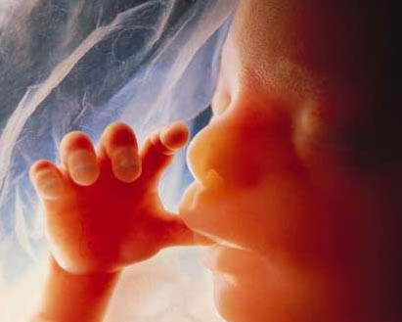

Learn More About

Wyandot County Right To Life:
Our website:
http://wyandotcountyrightolife.org/ (Note: right and to share a “t”)

We have had 16,059 views of the website as of June, 2015. Check us out!

~~~~~~~~~~~~~~~~~~~~~~~~~~~~~~~~~~~~~~~~~~~~~~~~~~~~~~~~~~~~~~~~~~~~~~~~~~
Our Facebook page:
https://www.facebook.com/WyandotCountyRightToLife
We hope you hit “Like” to show your approval!
“Human Life is Sacred… Conception Til Natural Death”

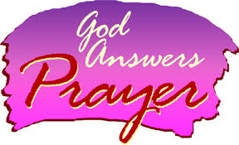
Pray to End Abortion: Daily Pro-life Reflections at: www.prolifereflectionsforeveryday.org.


LIFE Fair Booth: Please volunteer to staff the LIFE booth!!! Tuesday is Upper (Deb Rall), Wednesday is Sycamore St Pius (Doris Daniel), Thursday is Carey OLC (Jean Ann Hoepf), Friday is Kirby (Marie Frey), Saturday is Community Christian Center & Sunday is Bethel Pro-Life Ministries. If you or your church would like to volunteer we’d love to have your help to promote LIFE!!! The more witnesses in the booth the more comfortable passerby are about stopping to check out the booth. The fair them this year is “Cowboy Boots & Country Roots” To make it a LIFE theme we are adding “Cherish Life Born & Unborn”

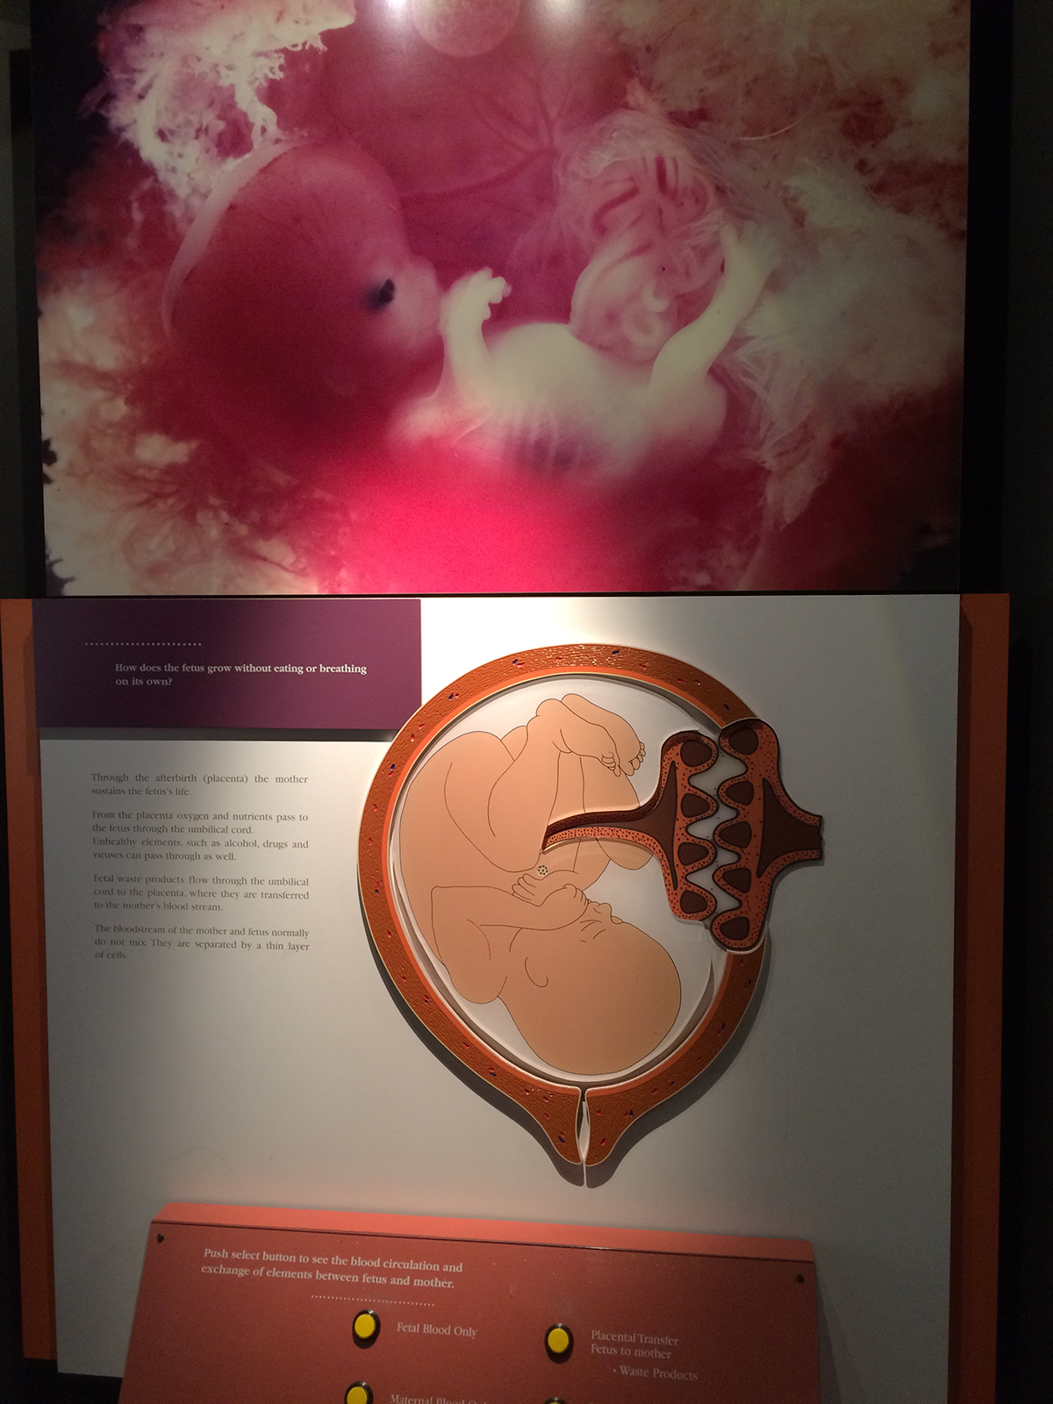
Prenatal Exhibit at the Oregon Museum of Science and Industry, or OMSI. Incredible display of miscarried babies shows the humanity of preborn children. The exhibit was created by Dr. Gunther von Hagens, the person behind the controversial “Body Worlds” exhibit. He uses a plastination technique to preserve animal and human bodies and sets up exhibits in an effort to educate people about anatomy in a way that books can’t. One area was an interactive display where you could push different buttons and LED lights would illuminate how the babies blood and the mother’s blood is kept separate, yet the mother’s body gives nutrition to the baby and carries away waste. There are 42 embryos and fetuses preserved in glass cases along the curved wall. They start at the youngest and as you walk through the exhibit the babies get progressively older, until you reach the last child who was 33 weeks old and had a full head of hair. Each baby has a sign under it giving the age from fertilization of the child and what is going on for a baby developmentally, at that age. The exhibit makes it clear that the ages attributed to the children is the actual time after fertilization, not LMP. (Want More: Incredible display of miscarried babies shows the humanity of preborn children by Josh Brahm, http://liveactionnews.org/incredible-display-of-miscarried-babies-shows-the-humanity-of-preborn-children/)
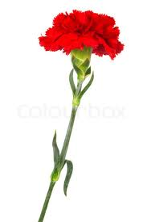
Annual Mother’s Day Red Carnation Sale - Thanks to everyone who bought one or more of the Red Carnations to honor the lady/ladies in their life and to help promote the LIFE cause. Special thanks to Community Christian Center & the Upper and Carey K of C for helping with this event!!!

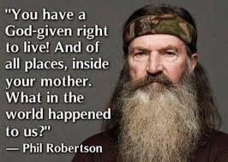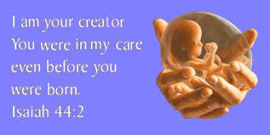

AudioGirl Ministries was founded in 2009 by two Catholic women who wanted to “do something” about the holocaust of 1.2 MILLION babies (4 in 10) who are brutally aborted in the US every year. Blessed to have grown to include a dedicated, joyfully spirited group of Catholic, Protestant and Jewish faithful, Team AGM promotes the TRUTH that every baby is a person whose beautiful beating heart deserves to be passionately protected and cherished. Learn how to speak up for our unborn brothers and sisters. Get The Power of 7 pro life app today! It’s FREE and available now at Google Play and the App Store. (Want More: http://audiogirlministries.com/)
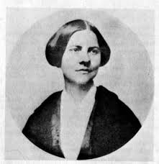
“Sweeter even than to have had the joy of children of my own has it been for me to help bring about a better state of things for mothers generally, so that their unborn little ones could not be willed away from them.” – Susan B. Anthony

The Billboard People - PROLIFE Across AMERICA is a non-profit, non-political organization dedicated to changing hearts & saving babies’ lives. Since 1989 we've been bringing positive, persuasive messages, offering information and alternatives – including adoption – and post abortion assistance to those in need. This group helps Wyandot Co Right to Life get the pro-life message out to Wyandot Countians and those passing through our county.
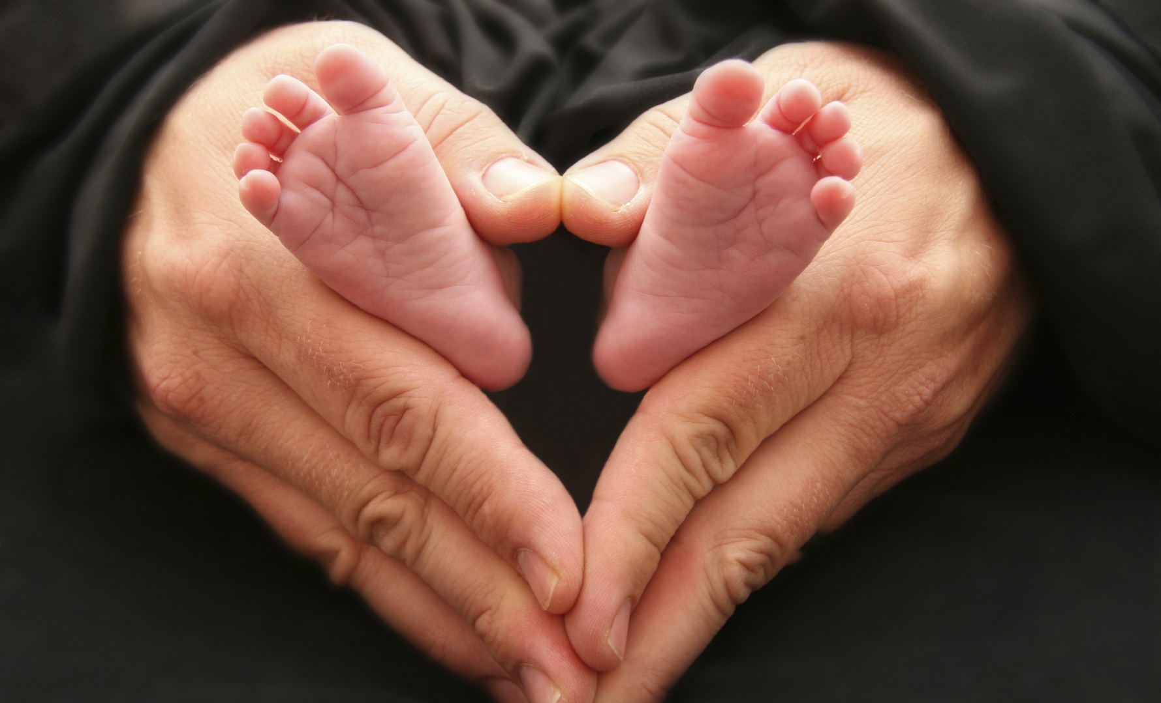
"The best thing I can show you to defend life is my life. It has been a great gift. I have met other survivors of abortion. They are all thankful for Life ... when I speak, I speak not only for myself, but for the other survivors ... and also those who cannot yet speak ... Today a baby is a baby when convenient. It is tissue or otherwise when the time is not right. A baby is a baby when miscarriage takes place at two, three, four months. Why is that? I see no difference."
--Gianna Jessen, saline abortion survivor who has overcome amazing odds

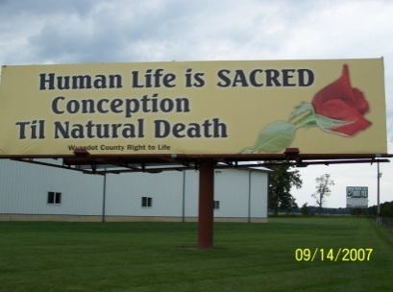
Wyandot County Right to Life
Non Profit
U.S. Postage
Paid
Marion, OH
Permit # 23
P.O. Box 381
Upper Sandusky, OH 43351-0381
RETURN SERVICE REQUESTED

~~~~~~~~~~~~~~~~~~~~~~~~~~~~~~~~~~~~~~~~~~~~~~~~~~~~~~~~~~

What Can I Do? 

- Pray for Respect for Human Life in our country and in the world. VOTE Pro-Life!
- Become a member of Wyandot County Right to Life ($6 dues donation)
- Work for Life – May we call you with volunteer opportunities? Yes PH_____________
- Support Wyandot County Right to Life with your gift of $________________________
If you choose your gift may be made
In Memory of (name) _______________________________________________________
Mailing Address____________________________________________________________
Or for a birthday, anniversary or special event
In Honor of (name) _________________________________________________________
Mailing Address____________________________________________________________
~~~~~~~~~~~~~~~~~~~~~~~~~~~~~~~~~~~~~~~~~~~~~~~~~~~~~~~~~~~~~~~~~~~~
**We regret that the federal government does not allow contributions to Wyandot County Right to Life to be tax deductible. If you would like your gift to be tax deductible, please make your check out to: Ohio Right to Life Educational Fund and in the
MEMO box mark for the use of: Wyandot Co Right to Life!!!! We will be able to use these funds for educational activities and you will have a tax deduction! Your gift is important to us. We are all volunteers, so every penny goes toward our mission of respecting and protecting human life from conception til natural death. Please mail to: Wyandot Co Right to Life P O Box 381 Upper Sandusky, OH 43351-0381. Thanks & God Bless You!!!

